Name –
Activity – Label the Parts of a Computer
Drag and drop each label next to the correct computer part
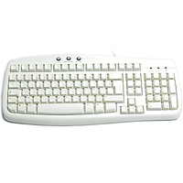
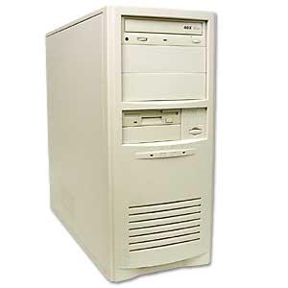
Power button

CD drive

Monitor

Keyboard

3½ floppy drive

Now print your work

Printer

Mouse

