Fitting In*
 | The Death of Jayson Porter  Adoff, Jaime  In the Florida projects, sixteen-year-old Jayson struggles with the harsh realities of his life which include an abusive mother, a drug-addicted father, and not fitting in at his predominately white school, and bring him to the brink of suicide.
 | Maria (Series: Coming Out, Book #4)  Aguilar-Zeleny, Sylvia  While living in Santa Barbara and attending a private school, Maria's life was comfortably boring. Then her sister died, her father lost his job, and the whole family was forced to start over. When they move to the barrio in East L.A. to live with Maria's grandma, Maria recovers her roots and becomes empowered. She can't continue hiding that she is a lesbian when she meets Natalia, a grumpy chola who smells like sugar and turns Maria's life upside down.
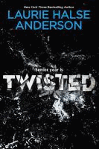 | Twisted  Anderson, Laurie Halse  After finally getting noticed by someone other than school bullies and his ever-angry father, seventeen-year-old Tyler enjoys his tough new reputation and the attentions of a popular girl, but when life starts to go bad again, he must choose between transforming himself or giving in to his destructive thoughts.
 | How I Got Skinny, Famous, and Fell Madly in Love  Baker, Ken  Emery Jackson signs up for a reality television weight loss show and discovers many truths.
 | I Am J  Beam, Cris  J, who feels that he is a boy who was mistakenly born a girl, hides who he is from his family and the world, but after he loses his best friend, J decides to stop hiding, whatever the cost.
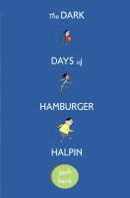 | The Dark Days of Hamburger Halpin  Berk, Josh  When Will Halpin transfers from his all-deaf school into a mainstream Pennsylvania high school, he faces discrimination and bullying, but still manages to solve a mystery surrounding the death of a popular football player in his class.
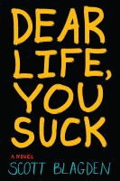 | Dear Life, You Suck  Blagden, Scott  Irreverent, foul-mouthed, seventeen-year-old Cricket Cherpin, living under the watchful eye of Mother Mary at a Catholic boys' home in Maine, has such bleak prospects he is considering suicide when Wynona Bidaban steps into his world.
 | A Different Me  Blumenthal, Deborah  High schooler Allie, who has long wanted to get plastic surgery, becomes online friends with two other girls who share her obsession.
 | Revenge of a Not-So-Pretty Girl  Blythe, Carolita  Fourteen-year-old Faye, an African American living in 1984 Brooklyn, New York, copes with her mother's abuse by stealing with her friends, but when robbing an elderly woman almost turns to murder, she gains an opportunity to learn new truths about life.
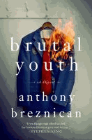 | Brutal Youth  Breznican, Anthony  Three freshmen must join forces to survive at a troubled, working-class Catholic high school with a student body full of bullies and zealots, and a faculty that's even worse in Anthony Breznican's Brutal Youth.
 | Private  Brian, Kate  Fifteen-year-old Reed Brennan wins a scholarship to an exclusive private school, and thinks she has finally found a way to escape her troubled home life, but when she arrives, the students are not what Reed expected and she struggles to find a way to fit in with the other girls.
 | Lucas  Brooks, Kevin  On an isolated English island, fifteen-year-old Caitlin McCann makes the painful journey from adolescence to adulthood through her experiences with a mysterious boy, whose presence has an unsettling effect on the island's inhabitants
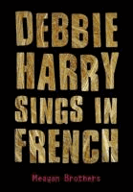 | Debbie Harry Sings in French Brothers, Meagan  When Johnny completes an alcohol rehabilitation program and his mother sends him to live with his uncle in North Carolina, he meets Maria, who seems to understand his fascination with the new wave band Blondie, and he learns about his deceased father's youthful forays into "glam rock," which gives him perspective on himself, his past, and his current life.
 | Alex as Well  Brugman, Alyssa  Raised as a boy, fourteen-year-old Alex, who has male and female sexual body parts, rejects the hormonal medications prescribed by his mother and decides to live as a girl.
 | Ask Me No Questions Budhos, Marina  Fourteen-year-old Nadira, her sister, and their parents leave Bangladesh for New York City, but the expiration of their visas and the events of September 11, 2001, bring frustration, sorrow, and terror for the whole family.
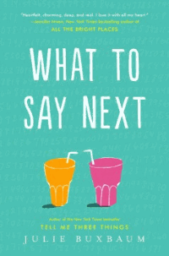 | What to Say Next  Buxbaum, Julie  When an unlikely friendship is sparked between relatively popular Kit Lowell and socially isolated David Drucker, Kit asks David for his help figuring out the how and why of her father's tragic car accident.
 | Beat the Band  Calame, Don  Paired with the infamous "Hot Dog" Helen for a health class presentation on safe sex, tenth-grader Coop tries to regain his "cool" by entering his musically challenged rock group in the "Battle of the Bands" competition.
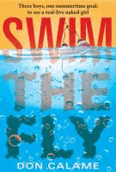 | Swim the Fly  Calame, Don  Swim team members and best friends Matt, Sean, and Coop, set themselves the summertime goal of seeing a live girl naked, and while the chances of that happening seem very dim, Matt's personal goal to swim the one-hundred-yard butterfly to impress the new girl on the team seems even less likely to happen.
 | Boy Proof  Castellucci, Carol  Feeling alienated from everyone around her, high school senior and cinephile Victoria Denton hides behind the identity of a favorite movie character until an interesting new boy arrives at school and helps her realize that there is more to life than just the movies.
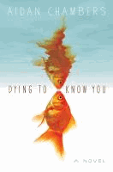 | Dying to Know You  Chambers, Aidan  Struggling through his dyslexia to try to fulfill his girlfriend Fiorella's request for a letter revealing his secret self, eighteen-year-old Karl asks Fiorella's favorite author for help, and he agrees only if Karl will submit to a series of interviews, which result in unexpected consequences for Karl, Fiorella, and the author.  Topics: Dyslexia, Death, Grief and Loss
 | Fat Angie  Charlton-Trujillo, e. E.  Fat Angie's sister was captured in Iraq, she is the resident laughingstock at school, and her therapist tells her to count instead of eat, but her life changes when she meets the daring new girl, KC Romance.
 | The Perks of Being a Wallflower  Chbosky, Stephen  Charlie, a freshman in high school, explores the dilemmas of growing up through a collection of letters he sends to an unknown receiver.  Other topics: suicide, drug abuse, and gay relationships
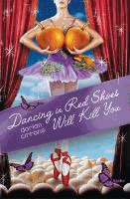 | Dancing in Red Shoes Will Kill You  Cirrone, Dorian  Sixteen-year-old Kayla, a ballet dancer with very large breasts, and her sister Paterson, an artist, are both helped and hindered by classmates as they confront sexism, conformity, and censorship at their high school for the arts while still managing to maintain their sense of humor.
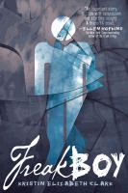 | Freakboy  Clark, Kristin Elizabeth  Told from three viewpoints, seventeen-year-old Brendan, a wrestler, struggles to come to terms with his place on the transgender spectrum while Vanessa, the girl he loves, and Angel, a transgender acquaintance, try to help.
 | Little Black Lies  Cohen, Tish  Starting her junior year at an ultra-elite Boston school, sixteen-year-old Sara, hoping to join the popular crowd, hides that her father not only is the school janitor, but also has obsessive-compulsive disorder.
 | Keep Holding On  Colasanti, Susane  Bullied at school and neglected by her poor, self-absorbed, single mother at home, high school junior Noelle finally reaches the breaking point after a classmate commits suicide.
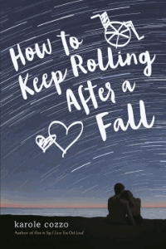 | How to Keep Rolling After a Fall  Cozzo, Karole  Mean girl Nikki Baylor, accused of a cyberbullying incident that nearly resulted in a classmate's suicide, is expelled from school, abandoned by her friends, and distrusted by her parents but she gets a second chance after meeting Pax, a spirited wheelchair rugby player.
 | Period.8  Crutcher, Chris  Period 8 has always been a safe haven and high school senior Paulie "The Bomb" Baum a constant attendee, but as Paulie, Hannah, their friends, and a sympathetic teacher try to unravel the mystery of a missing classmate, the ultimate bully takes aim at the school.
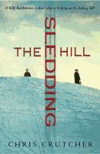 | The Sledding Hill  Crutcher, Chris  Billy, recently deceased, keeps an eye on his best friend, fourteen-year-old Eddie, and helps him stand up to a conservative minister and English teacher who is orchestrating a censorship challenge.
 | Played  Davidson, Dana  Kylie Winship is overwhelmed by the attention she is getting from handsome Ian Striver; however, when the relationship begins to heat up, Kylie must decide whether to listen to her heart or her head.
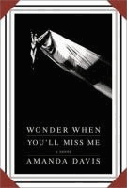 | Wonder When You’ll Miss Me  Davis, Amanda  Sixteen-year-old Faith Duckle embarks on a journey of discovery when she runs off with the circus after attacking one of the boys who raped her the year before.
 | Keeping the Moon  Dessen, Sarah  Fifteen-year-old Colie, a former fat girl, spends the summer working as a waitress in a beachside restaurant, staying with her overweight and eccentric Aunt Mira, and trying to explore her sense of self.
 | What Happened to Goodbye  Dessen, Sarah  Seventeen-year-old Mclean begins to lose sight of who she really is after she tries to reinvent herself at each school she attends after her parents' divorce and her father moves her from town to town.
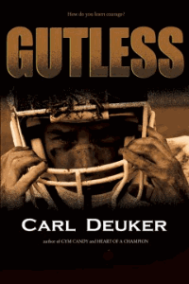 | Gutless  Deuker, Carl  With both good speed and good hands, wide receiver Brock Ripley should be a natural for the varsity team, but he shies from physical contact. When his issues get him cut from varsity, he also loses his friendship with star quarterback Hunter Gates. Now a target for bullying, Brock struggles to overcome his fears and discover that, in his own way, he is brave enough.
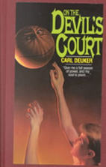 | On the Devil’s Court  Deuker, Carl  Struggling with his feelings of inadequacy and his failure to make the basketball team in his new school, seventeen-year-old Joe Faust finds himself willing to trade his soul for one perfect season of basketball.
 | Press Play (2015) Print and e book  Devine, Eric  Greg Dunsmore, who is bullied for being overweight and is making a documentary of his weight loss to get into film school, records footage of hazing by his town's championship-winning lacrosse team, and he must decide whether or not to expose it.  Issue: Bullying
 | Blind  DeWoskin, Rachel  After a horrific accident leaves her blind, fifteen-year-old Emma, one of seven children, eagerly starts high school as a sophomore, and finds that nearly everything has changed--sometimes for the better.
 | Down to the Bone  Dole, Mayra Lazara  Laura, a Miami high school student, gets caught kissing her lesbian lover which marks the start of big changes in her life, including getting kicked out of her Catholic school, thrown out of her home by her mother, and forced to build a new kind of family with the help of friends and supporters.
 | Gallows Hill  Duncan, Lois  When seventeen-year-old Sarah works in the fortune-telling booth at a school carnival, she finds that sometimes she can really see the future in the crystal ball.
 | Girls Can’t Hit  Easton, T.S.  After not being allowed to take a boxing class at her school because she is a girl, Fleur deals with bullying and disapproval in her quest to set things right and ensure equal opportunity for all students.
 | Happyface  Emond, Stephen  After going through traumatic times, a troubled, socially awkward teenager moves to a new school where he tries to reinvent himself.
 | Outcast  Ewing, Lynne  Kyle, a teenage artist living in Los Angeles with his three roommates, all on the run from the dark world of Nefandus, struggles to understand the lies his friends are telling about him, begins to suspect that he is losing time, and finds himself pursued by an evil entity from his past.
 | Tell Me Again How a Crush Should Feel  Farizan, Sara  High school junior Leila's Persian heritage already makes her different from her classmates at Armstead Academy, and if word got out that she liked girls life would be twice as hard, but when a new girl, Saskia, shows up, Leila starts to take risks she never thought she would, especially when it looks as if the attraction between them is mutual, so she struggles to sort out her growing feelings by confiding in her old friends.
 | Top 8  Finn, Katie  After her online profile is hacked, Madison, a popular junior at her high school, is forced to reevaluate some important things in her life while trying to figure out who committed the crime, fixing her reputation, and regaining her boyfriend's trust.
 | Born Ugly  Goobie, Beth  Shir has always tried to be invisible, but is still tormented by the bullies at her school and treated like an outcast in her own home, leaving her with only two places where she feels she can escape--at her part-time job delivering groceries and at her secret retreat by the river--but when her job leads her into a world of uncertainty and a stranger invades her haven by the river, Shir's whole world is turned upside down.
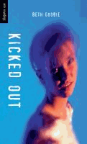 | Kicked Out  Goobie, Beth  Sixteen-year-old Dime has difficulty adjusting to her parents' rules.
 | The Lottery  Goobie, Beth  Fifteen-year-old Sally Hanson, chosen as the latest victim of the Shadow Council, the secret club that controls school life, finds the strength to stand up to the bullies with the help of her brother and other special friends.
 | The Throne: a novel  Goobie, Beth  Meredith is determined to make her mark as she starts Grade 10--and claiming the "cool" seat in home room is her first step. But that decision brings her unwanted attention from the school's "kingpin of the underworld" and her new enemy is smart, determined and capable of holding a long-term grudge. Should she just back away? But how will she look at herself in the mirror if she does? With the help of her two best friends, Reb and Dean, she will have to find a way to stand up for herself and survive high school with her dignity intact.
 | Looking for Alaska  Green, John  Sixteen-year-old Miles' first year at Culver Creek Preparatory School in Alabama includes good friends and great pranks, but is defined by the search for answers about life and death after a fatal car crash.
 | Will Grayson, Will Grayson  Green, John, and David Levithan  When two teens, one gay and one straight, meet accidentally and discover that they share the same name, their lives become intertwined as one begins dating the other's best friend, who produces a play revealing his relationship with them both.
 | The Last Exit to Normal  Harmon, Michael B.  Yanked out of his city life and plunked down in a small Montana town with his newly outed father and his father's boyfriend, seventeen-year-old Ben, angry and resentful about the changed circumstances of his life, begins to notice something is not quite right with the little boy next door and determines to figure out what is going on.
 | Best Friends for Never  Harrison, Lisa  A bet about wardrobes between the wealthy Massie and middle-class Claire results in a testing of old friendships, a forging of new ones, and a change for the student body at Octavian Country Day School.
 | Boys r Us  Harrison, Lisa  Massie Block forms a new clique, but old rivalries, new relationships, and petty jealousies threaten to destroy Massie and her friends.
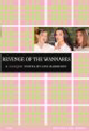 | Revenge of the Wannabes: a clique novel  Harrison, Lisa  Friendships are tested when Alicia, a seventh grader at Octavian Country Day School, decides to break away from the exclusive clique led by her best friend to start her own group.
 | Before You  Hart, Amber  Faith Watter, living the picture-perfect life, falls in love with Diego Alavarez, a bad boy and recent immigrant from Cuba who does not like his new life in the United States and is hiding a secret past, and while everyone knows they should not be together, all they want is to be free.
 | The Order of the Poison Oak  Hartinger, Brent  Sixteen-year-old Russel, having endured the antagonism of his classmates since admitting he is homosexual, decides to take a counselor job at a summer camp for burn victims, but finds ten-year-old boys have just as many problems as he does.
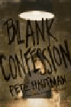 | Blank Confession  Hautman, Pete  A new and enigmatic student named Shayne appears at high school one day, befriends the smallest boy in the school, and takes on a notorious drug dealer before turning himself in to the police for killing someone.
 | Kiss Me Kill Me  Henderson, Lauren  Longing to be part of the in-crowd at her exclusive London school, orphaned, sixteen-year-old Scarlett, a trained gymnast, eagerly accepts an invitation to a party whose disastrous outcome changes her life forever.
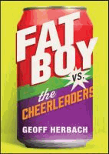 | Fat Boy vs. the Cheerleaders  Herbach, Geoff  When the high school cheerleading team takes over a soda vending machine's funds, which were previously collected by the pep band, Gabe Johnson, an overweight "band geek" tired of being called names and looked down on, declares war.
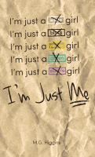 | I’m Just Me  Higgins, M.G.  Two very different girls unite when bullying escalates at their high school.
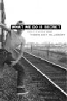 | What We Do is Secret  Hillsberry, T.K.  Street kid and hustler Rocket Redglare realizes he has come to a turning point in his life after his closest friend commits suicide, and Rocket struggles to find a way to get off the streets before it is too late.
 | Anything But Ordinary  Hobbs, Valerie  High school sweethearts Bernie and Winifred face the difficulties of a long distance relationship when their plans to attend college together are ruined by the death of Bernie's mother, and Winifred decides to attend the University of California at Santa Barbara, where she changes her identity in order to fit in, while he stays in New Jersey.
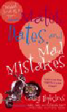 | Mates, Dates, and Mad Mistakes  Hopkins, Cathy  British teen Izzy tries to spread her wings but soon finds herself thwarted by her mother, shunned by her friends, and confused and a bit frightened by her older, somewhat wild boyfriend, Josh.
 | Rumble  Hopkins, Ellen  Eighteen-year-old Matt's atheism is tested when, after a horrific accident of his own making that plunges him into a dark, quiet place, he hears a voice that calls everything he has ever disbelieved into question.
 | The Misfits  Howe, James  Four students who do not fit in at their small-town middle school decide to create a third party for the student council elections to represent all students who have ever been called names.
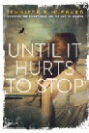 | Until it Hurts to Stop  Hubbard, Jennifer  A former victim of middle school bullying, seventeen-year-old Maggie struggles to navigate the high school world of love and friendships, finding solace in her love of hiking.
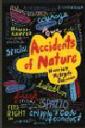 | Accidents of Nature  Johnson, Harriet McBryde  Having always prided herself on blending in with "normal" people despite her cerebral palsy, seventeen-year-old Jean begins to question her role in the world while attending a summer camp for children with disabilities.
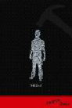 | Nailed  Jones, Patrick  An outcast in a school full of jocks, sixteen-year-old Bret struggles to keep his individuality through his interest in drama and music, while trying to reconnect with his father.
 | Wired Man and Other Freaks of Nature  Kaufman, Sashi  Ben has to wear hearing aids, but being inseparable from the super-popular Tyler allows him to think of himself as normal. But Tyler blows him off senior year and Ben needs to rethink who he is--and who Tyler is.
 | Harmonic Feedback  Kelly, Tara  When Drea and her mother move in with her grandmother in Bellingham, Washington, the sixteen-year-old finds that she can have real friends, in spite of her Asperger's, and that even when you love someone it does not make life perfect.
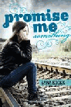 | Promise Me Something  Kocek, Sara  When Reyna Fey starts high school at a new school, she plans to keep to herself and help her father recover from the accident that almost killed him, but she did not expect to meet Olive, a brash, opinionated outcast, who befriends her. Soon, Reyna learns something about Olive that forces her to decide if her new friendship is worth becoming an outcast herself.
 | Stoner & Spaz  Koertge, Ronald  A troubled youth with cerebral palsy struggles toward self-acceptance with the help of a drug-addicted young woman.
 | Openly Straight  Konigsberg, Bill  Tired of being known as "the gay kid", Rafe Goldberg decides to assume a new persona when he comes east and enters an elite Massachusetts prep school--but trying to deny his identity has both complications and unexpected consequences.
 | Jake, Reinvented  Korman, Gordan  When Jake Garrett arrives at F. Scott Fitzgerald High, the students immediately take a liking to him and he becomes one of the most popular boys in school, but when a dark secret is revealed, the same students begin to fear him.
 | Heavy Metal and You  Krovatin, Christopher  High schooler Sam begins losing himself when he falls for a preppy girl who wants him to give up getting wasted with his best friends and even his passion for heavy metal music in order to become a better person.
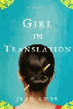 | Girl in Translation  Kwok, Jean  Ah-Kim Chang and her mother immigrate to Brooklyn, where they work for Kim's Aunt Paula in a Chinatown clothing factory earning barely enough to keep them alive; however, Kim's perseverance and hard work earns her a place at an elite private school where she is befriended by Annette, who helps her adjust to American culture.
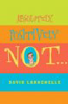 | Absolutely, Positively Not  LaRochelle, David  Chronicles a teenage boy's humorous attempts to fit in at his Minnesota high school by becoming a macho, girl-loving, "Playboy" pinup-displaying heterosexual.
 | The Singing Mountain  Levitin, Sonia  While traveling in Israel for the summer, seventeen-year-old Mitch decides to stay and pursue a life of Jewish orthodoxy, forcing him to make some important decisions about the family and life he is leaving in southern California.
 | Life, After  Littman, Sarah Darer  When poverty forces her family to leave their home in Buenos Aires, Argentina, Dani has a hard time adjusting to life in New York City, where everything is different except her father's anger, but an unlikely bond she forms with a wealthy, spoiled girl at school helps heal both of their families.
 | Angry Young Man  Lynch, Chris  A boy reaches an unimaginable conclusion when he takes a journey of self-discovery.
 | Slot Machine  Lynch, Chris  When overweight thirteen-year-old Elvin Bishop is sent to camp at Christian Brothers Academy Retreat Center, he and his two best friends are forced to try various sports in order to find out where they belong.
 | Silence  Lytton, Deborah  After an accident robs Stella of her hearing and her dream of going to Broadway, she meets Hayden, a boy who stutters, and comes to learn what it truly means to connect and communicate in a world filled with silence.
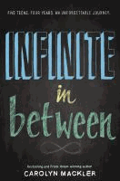 | Infinite in Between  Mackler, Carolyn  Five students who meet in freshman orientation agree to write notes to their future selves and promise to reunite in exactly four years when they are ready to graduate from high school.
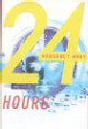 | 24 Hours  Mahy, Margaret  During his first twenty-four hours after finishing high school, seventeen-year-old Ellis unexpectedly becomes part of an inner-city world far different from his comfortable life, which helps deal with his best friend's recent suicide.
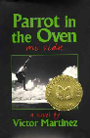 | Parrot in the Oven: mi vida: a novel  Martinez, Victor  Manny relates his coming of age experiences as a member of a poor Mexican American family in  which the alcoholic father only adds to everyone's struggle.
 | Drowning Anna  Mayfield, Sue  Brainy, shy Anna Goldsmith, having moved from London to Yorkshire, is thrilled to be befriended by Hayley Parkin, the most popular girl in her new school, but over the course of several years it becomes evident that Hayley's motives are not at all kind.
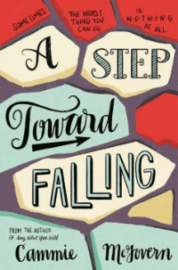 | A Step Toward Falling  McGovern, Cammie  When Emily sees her developmentally disabled classmate Belinda being attacked, she does nothing at all. Belinda, however, manages to save herself. When their high school finds out what happened, Emily and Lucas, a football player who was also there that night, are required to perform community service at a center for disabled people. But can they do anything that that will actually help the one person they hurt the most?
 | The Knife that Killed Me  McGowan, Anthony  Paul Varderman, a secondary student in an English Catholic School, is a loner until, just as he is becoming friends with "the freaks," the school bully encourages Paul to join his gang and gives him a knife to carry as an incentive.
 | Not Otherwise Specified  Moskowitz, Hannah  Auditioning for a New York City performing arts high school could help Etta escape from her Nebraska all-girl school, where she is not gay enough for her former friends, not sick enough for her eating disorders group, and not thin enough for ballet, but it may also mean real friendships.
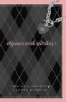 | Rhymes with Witches  Myracle, Lauren  High school freshman Jane believes that she would do anything to be popular until she is selected to be in the school's most exclusive clique and learns that popularity has a price.
 | Shine  Myracle, Lauren  When her best friend falls victim to a vicious hate crime, sixteen-year-old Cat sets out to discover the culprits in her small North Carolina town.
 | The Fold  Na, An  Joyce Park, a high school junior who is always compared to her beautiful and talented older sister, Helen, wants to attract the attention of John Ford Kang, and wrestles with whether to get plastic surgery as a gift from her aunt.
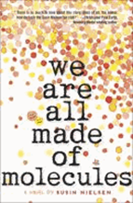 | We Are All Made of Molecules  Nielsen, Susin  Thirteen-year-old brilliant but socially-challenged Stewart and mean-girl Ashley must find common ground when, two years after Stewart's mother died, his father moves in with his new girlfriend--Ashley's mother, whose gay ex-husband lives in their guest house.
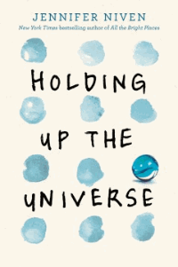 | Holding Up the Universe  Niven, Jennifer  A boy with face blindness and a girl who struggles with weight fall in love.
 | Art Geeks and Prom Queens  Noel, Alyson  Seventeen-year-old Alex struggles to fit in at her new private school in Southern California until she meets the very popular Kristi; however, the deeper she becomes immersed in her new crowd, the more she realizes Kristi is not to be messed with.
 | Kiss and Blog  Noel, Alyson  Best friends Winter and Sloane make a pact to do whatever it takes to get noticed in their sophomore year, but once Sloane is taken up by the "popular" crowd, she quickly leaves Winter behind, and Winter must consider the consequences when she decides to take revenge by airing all of Sloane's secrets on an anonymous blog.
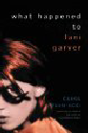 | What Happened to Lani Garver  Plum-Ucci, Carol  Sixteen-year-old Claire is unable to face her fears about a recurrence of her leukemia, her eating disorder, her need to fit in with the popular crowd on Hackett Island, and her mother's alcoholism until the enigmatic Lani Garver helps her get control of her life at the risk of his own
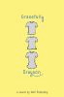   | Gracefully Grayson  Polonsky, Ami  Grayson, a transgender twelve-year-old, learns to accept her true identity and share it with the world.  King Dork  Portman, Frank  High school loser Tom Henderson discovers that The Catcher in the Rye may hold the clues to the many mysteries in his life.
 | Boy 21  Quick, Matthew  Finley, an unnaturally quiet boy who is the only white player on his high school's varsity basketball team, lives in a dismal Pennsylvania town that is ruled by the Irish mob, and when his coach asks him to mentor a troubled African American student who has transferred there from an elite private school in California, he finds that they have a lot in common in spite of their apparent differences.  Other Topics: Race Relations, Disabilities, Murder, Gangs
 | Maybe  Runyon, Brent  Sixteen-year-old Brian struggles with life at a new school, his sexual desires, and his unresolved feelings about the loss of his older brother.
 | This Song Will Save Your Life  Sales, Leila  Nearly a year after a failed suicide attempt, sixteen-year-old Elise discovers that she has the passion, and the talent, to be a disc jockey.
 | A Boy Called Twister  Schraff, Anne  Kevin Walker is determined to be a loner at Tubman High so no one will discover the secret that forced his family to move, but when he becomes the star of the track team, his rising popularity threatens everything.
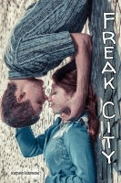 | Freak City  Schrocke, Kathrin  Mika, heartbroken over his breakup with his ex-girlfriend, meets Leah. He is instantly drawn to her but learns there is something different about Leah--she is deaf. Mika learns sign language so he can communicate with her, but discovers the world of deaf culture is much different from his own. Soon, Mika and Leah find that extraordinary love overcomes all obstacles.
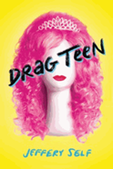 | Drag Teen: a tale of angst and wigs  Self, Jeffery  JT is a gay high school senior determined to get out of Clearwater, Florida, and be the first person in his family to go to college, even though he can not figure out how to pay for it--until his friends convince him to compete in a drag teen competition where the first prize is a college scholarship.
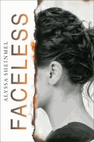 | Faceless  Sheinmel, Alyssa  Maisie is a normal sixteen-year-old, until an electrical fire caused by a lightning strike leaves her with severe burns, her face partially destroyed--she is lucky enough to get a full face transplant but she soon discovers how much her looks shaped her own identity and her relationship with those around her, including her boyfriend.
 | Project X  Shepard, Jim  Eighth-grade misfits Edwin Hanratty and his only friend, Flake, feed each other's misery and discontent until they decide the only solution is violence.
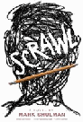 | Scrawl  Shulman, Mark  When eighth-grade school bully Tod and his friends get caught committing a crime on school property, his penalty--staying after school and writing in a journal under the eye of the school guidance counselor--reveals aspects of himself that he prefers to keep hidden.
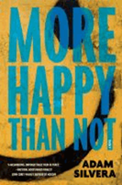 | More Happy Than Not  Silvera, Adam  After enduring his father's suicide, his own suicide attempt, broken friendships, and more in the Bronx projects, Aaron Soto, sixteen, is already considering the Leteo Institute's memory-alteration procedure when his new friendship with Thomas turns to unrequited love.
 | Geek Girl  Smale, Holly  Harriet Manners is a geek. As if the Oxford English Dictionary on her nightstand isn't enough of a clue, there are also the weird looks she gets at school, and the way no one appreciates her extensive trivia knowledge. So when her friend Nat drags her along to a fashion show and Harriet is accidentally discovered by a modeling agent, she leaps at the chance to reinvent herself.
 | What My Girlfriend Doesn’t Know  Sones, Sonya  Artistic fourteen-year-old Robin Murphy is so unpopular at high school that his name is slang for "loser," so when he begins dating the beautiful and popular Sophie, her reputation plummets.
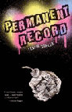 | Permanent Record  Stella, Leslie  Sixteen-year-old Badi Hessamizadeh struggles with his Iranian-American identity, depression, and bullying while at a new school under the name of Bud Hess, but after strange letters arrive at the local newspaper, suspicion falls on Bud and he and his new friend, Nikki, try to uncover who is really to blame.
 | Freak Show  St. James, James  Having faced teasing that turned into a brutal attack, Christianity expressed as persecution, and the loss of his only real friend when he could no longer keep his crush under wraps, seventeen-year-old Billy Bloom, a drag queen, decides the only to become fabulous again is to run for Homecoming Queen at his elite, private school near Fort Lauderdale, Florida.
 | Marcelo in the Real World  Stork, Francisco X.  Marcelo Sandoval, a seventeen-year-old boy on the high-functioning end of the autistic spectrum, faces new challenges, including romance and injustice, when he goes to work for his father in the mailroom of a corporate law firm.
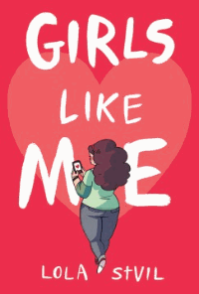 | Girls Like Me  Stvil, Lola  Fifteen-year-old Shay is trying to cope with being overweight and getting bullied in school, but when she falls in love with mysterious Blake, insecure Shay needs the help of her two best friends to make love prevail.
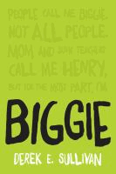 | Biggie  Sullivan, Derek E.  Henry "Biggie" Abbott has hidden behind his weight for years, and although he is the son and stepson of two of Finch, Minnesota's most famous athletes, he prefers academic success until the girl of his dreams suggests he join the baseball team, and, with his stepbrother's help, he discovers he is a great pitcher.
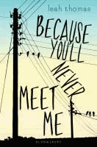 | Because You’ll Never Meet Me  Thomas, Leah  Ollie, who has seizures when near electricity, lives in a backwoods cabin with his mother and rarely sees other people, and Moritz, born with no eyes and a heart defect that requires a pacemaker, is bullied at his high school, but when a physician who knows both suggests they begin corresponding, they form a strong bond that may get them through dark times.
 | Breathless  Warman, Jessica  At boarding school, Katie tries to focus on swimming and becoming popular instead of the painful memories of her institutionalized schizophrenic older brother.
 | Black Mirror: a novel  Werlin, Nancy  Convinced her brother's death was murder rather than suicide, sixteen-year-old Frances begins her own investigation into suspicious student activities at her boarding school.
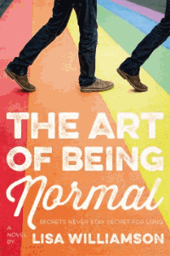 | The Art of Being Normal  Williamson, Lisa  David Piper, always an outsider, forms an unlikely friendship with Leo Denton who, from the first day at his new school wants only to be invisible, but when David's deepest secret gets out, that he wants to be a girl, things get very messy for both of them.
 | What They Always Tell Us  Wilson, Martin  Sixteen-year-old Alex feels so disconnected from his friends that he starts his junior year at a Tuscaloosa, Alabama, high school by attempting suicide, but soon, a friend of his older brother draws him into cross-country running and a new understanding of himself.
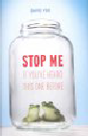 | Stop Me if You’ve Heard This One Before  Yoo, David  Despite his nonexistent social standing at Bern High School, Albert spends the summer working with his crush, Mia--the popular ex-girlfriend of Ryan Stackhouse--but as soon as Albert makes headway in his relationship with Mia, Ryan is diagnosed with cancer and pulls Mia, and her attention, away.
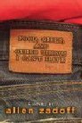 | Food, Girls, and Other Things I Can't Have  Zadoff, Allen  Fifteen-year-old Andrew Zansky, the second fattest student at his high school, joins the varsity football team to get the attention of a new girl on whom he has a crush.
 | Story of a Girl  Zarr, Sara  During the summer after her sophomore year, Deanna Lambert tries to come to terms with the reputation with which she was slapped in the eighth grade when she was caught by her father in the backseat of a car with a high school senior, and struggles with her still-strained relationship with her father and her changing feelings for her best friend, Jason.
 | The Secret Rites of Social Butterflies  Zindel, Lizabeth  Sixteen-year-old Maggie's fears about making friends as an incoming senior at an exclusive New York City girls school are allayed when she is invited to join an elite secret society devoted to eavesdropping and recording the "truth" about students and faculty.

*Plot summaries and images provided by Follett.

