Brain and Spinal cord
- Reflex – rapid, predictable, and involuntary responses to stimuli
- Reflex arc – direct route from a sensory neuron, to an interneuron, to an effector
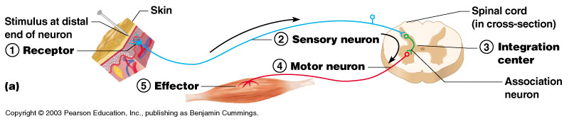
Regions of the Brain
- Cerebral hemispheres
- Diencephalon
- Brain stem
- Cerebellum

Cerebral Hemispheres (Cerebrum)
- Paired (left and right) superior parts of the brain
- Include more than half of the brain mass
- The surface is made of ridges (gyri) and grooves (sulci)
- Fissures (deep grooves) divide the cerebrum into lobes
- Surface lobes of the cerebrum
  - Frontal lobe
  - Parietal lobe
  - Occipital lobe
  - Temporal lobe
Specialized Areas of the Cerebrum
- Somatic sensory area – receives impulses from the body’s sensory receptors
- Primary motor area – sends impulses to skeletal muscles
- Broca’s area – involved in our ability to speak
- Cerebral areas involved in special senses
- Interpretation areas of the cerebrum
Layers of the Cerebrum
- White matter
  - Fiber tracts inside the gray matter
  - Example: corpus callosum connects hemispheres
Gray matter
  - Outer layer
  - Composed mostly of neuron cell bodies

Diencephalon
- Sits on top of the brain stem
- Enclosed by the cerebral hemispheres
- Made of three parts
  - Thalamus
  - Hypothalamus
  - Epithalamus
Thalamus
- The relay station for sensory impulses
- Transfers impulses to the correct part of the cortex for localization and interpretation
Hypothalamus
- Under the thalamus
- Important autonomic nervous system center
  - Helps regulate body temperature
  - Controls water balance
  - Regulates metabolism
- An important part of the limbic system (emotions)
- The pituitary gland is attached to the hypothalamus
Epithalamus
- Houses the pineal body (an endocrine gland)
- Includes the choroid plexus – forms cerebrospinal fluid

Brain Stem
- Attaches to the spinal cord
- Parts of the brain stem
  - Midbrain
  - Pons
  - Medulla oblongata
Midbrain
- Reflex centers for vision and hearing
Pons
- The bulging center part of the brain stem
- involved in the control of breathing
Medulla Oblongata
- The lowest part of the brain stem
- Merges into the spinal cord
- Contains important control centers
  - Heart rate control
  - Blood pressure regulation
  - Breathing
  - Swallowing
  - Vomiting

Cerebellum
- Two hemispheres with convoluted surfaces
- Provides involuntary coordination of body movements

Protection of the Central Nervous System
- Scalp and skin
- Skull and vertebral column
- Meninges
- Cerebrospinal fluid
- Blood brain barrier
Meninges
- Dura mater
  - Double-layered external covering
    - Periosteum – attached to surface of the skull
    - Meningeal layer – outer covering of the brain
- Arachnoid layer
  - Middle layer- Web-like
- Pia mater
  - Internal layer- Clings to the surface of the brain

Cerebrospinal Fluid
- Similar to blood plasma composition
- Formed by the choroid plexus
- Forms a watery cushion to protect the brain
- Circulated in arachnoid space, ventricles, and central canal of the spinal cord

Blood Brain Barrier
- Includes the least permeable capillaries of the body
- Excludes many potentially harmful substances
- Useless against some substances
  - Fats and fat soluble molecules
  - Respiratory gases
  - Alcohol
  - Nicotine
  - Anesthesia

Spinal Cord
- Extends from the medulla oblongata to the region of T12
- Below T12 is the cauda equina (a collection of spinal nerves)
- Enlargements occur in the cervical and lumbar regions
- Exterior white mater – conduction tracts
- Internal gray matter - mostly cell bodies
  - Dorsal (posterior) horns
  - Anterior (ventral) horns
- Meninges cover the spinal cord
- Nerves leave at the level of each vertebrae
Spinal Nerves
- There is a pair of spinal nerves at the level of each vertebrae for a total of 31 pairs

