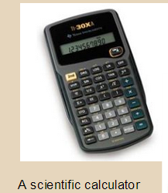 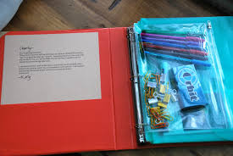

**Chemistry Class Supply List**

* **​1.5-2" Three-ring Binder with 6 dividers and a small amount of lined paper.**
* **THE BINDER IS TO BE KEPT IN CHRONOLOGICAL ORDER AND IS CONSIDERED THE STUDENT’S PORTFOLIO**
* **THE BINDER IS BROUGHT TO CLASS EACH DAY**

**Supplies: Our primary workspace and the student’s work product/portfolio is a 1.5” to 2” three-ring binder (anything smaller will not work) with 5 or 6 dividers and a neat cover.**

**Also bring student planners, pencils and pens, colored pencils, markers and/or highlighters and a scientific calculator.**

**Binder Sections *in chronological order*  as follows:**

**reference / notes / Worksheets / labs / tests&quizzes**

