Tools for Formative Assessment
Flipgrid-  FlipGrid samples and help: https://padlet.com/elizabethpitel8/c7s6f6jks1rz |  | 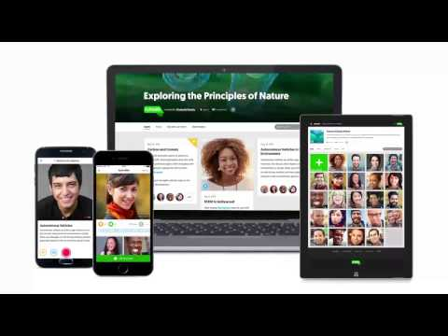
Quizizz- Fun multiplayer classroom quizzes. Built especially for review. Can be done in class together, or independently using homework settings. High interest and competition coupled with strong feedback tools.  https://quizizz.com/admin/quiz/5  68c167acfef0a581aa72150 | 
Socrative- An easy to use formative assessment tool that allows for teachers to check data on preplanned questions, or on the fly. Student data is saved and can be exported for later use. Immediate feedback is given on multiple choice questions and short answers can be discussed without student names |  | 
Kahoot- Whole group review quizzes that emphasize competition but also provide feedback for individual students while keeping track of the data. |  | 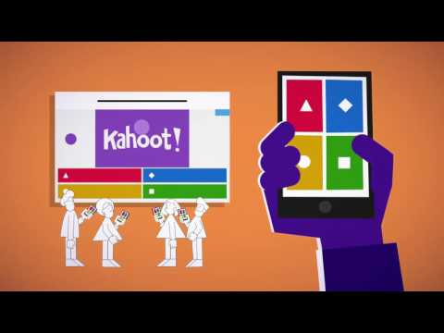
GoFormative- Online formative assessment that collects data and provides feedback for a variety of question types. Teachers can pre-plan questions and mix together various types of questions and media and monitor student answers on their device. Students even can draw out/label or show their work using an interactive whiteboard. |  | 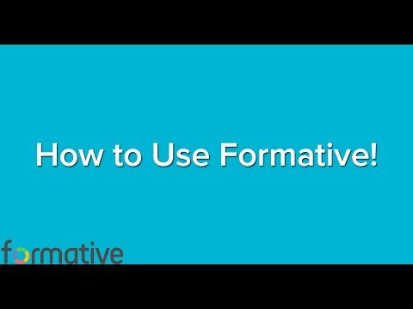
Nearpod- presentation tool that allows for assessment, collaboration, Virtual Reality, video access, simulations, in either the whole group or individual (italicized features are premium)  Sample lessons:  https://share.nearpod.com/yqJ1kJqzYL  Nearpod Help:  https://padlet.com/elizabethpitel8/c7s6f6jks1rz |  | What is Nearpod?    Virtual Field Trips  

