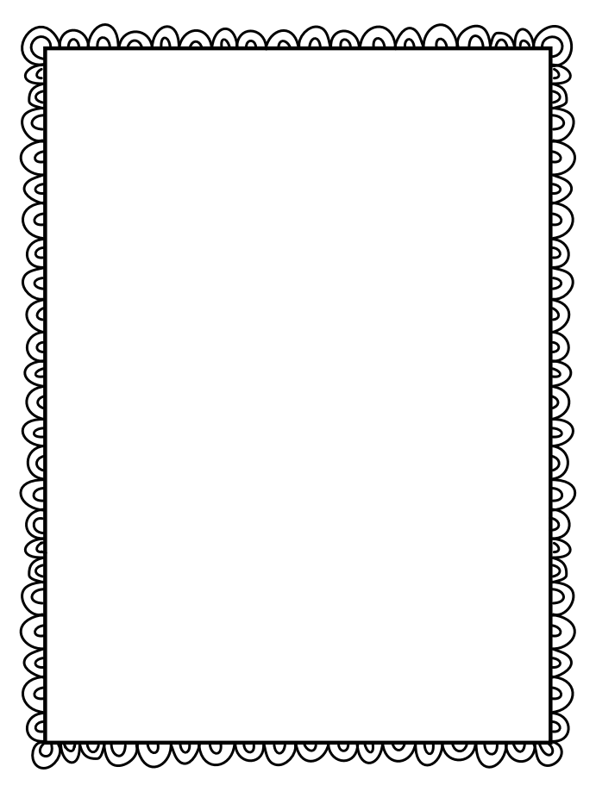

#### The Project

Decorate a box/bag to represent the book and fill it with objects that represent different parts of the book.

#### The Details

* + **You can use a small box or paper bag or other similarly sized container for this project.**
  + **Decorate your box/bag to go with the book. You can draw pictures yourself or use pictures from magazines or the Internet. Be sure to include the title and author of the book on the box as well as your name, date, and period.**
  + **Find at least 8 different objects. You can use pictures of the object you want to use if it is too big to fit inside your box.**
  + **For each object, name the object and describe how the object is an important/major part of the book. Be sure to be specific so that you can prove that you have read and understand the book.**

#### Tips for Success

✓✓ If you use pictures, glue them onto an index card backing to make them more durable and appealing.

✓✓ Try to find one object for each chapter or major event

of the book.

**Name**

**Due Date**

**Title of Book**





**Name _____________________ Book Title ______________________**

|  |  |
| --- | --- |
| Overall Presentation of the Box (EXTRA CREDIT)   * **Shoe box/bag is fully decorated appropriately with at least five images that relate to the book. (5 points)** * **Decorations are appealing, neat, and time was taken in creating box. (10 points)** * **At least 8 objects were included. (10 points)** |  |
| Quality (100 points)   * **Present detailed description that proves that you have read and understand the book. (40 points)** * **Be sure to speak clearly and look at the camera. (10 points)** * **At least 8 objects that represent important/major elements from the book. (40 points)** * **States name, period, title, and author (10 points)** |  |
| Teacher Comments:  Total Score |  |