Name___________________________________________________________________

Homeroom Teacher_______________________________________________________

Study Guide for Spanish Test

Complete this Study Guide and check your answers on the Spanish Test Review page on my webpage. You may also play the practice games on that page to study for the test.

A. Write the letter of the greeting you would use for the time of the day in the picture.

1. _____ Buenos días A. 

2. _____ Buenas tardes B. 

3. _____ Buenas noches C. 

B. Using the words in the word bank, complete the conversation below.

Adiós Tengo 10 años Me llamo María Hola

José: Buenos días.

María: ___________.

José: Me llamo José. ¿Cómo te llamas?

María: _________________.

José: Tengo 11 años. ¿Cuántos años tienes?

María: _________________.

José: Hasta la vista.

María: ___________.

C. Circle the word that corresponds with each picture.

1. a. Siéntate b. Carpeta c. Escucha

2. 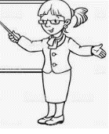 a. Sacapuntas b. Maestra c. Papel

3. 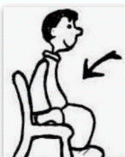 a. Habla b. Ventana c. Siéntate

4. 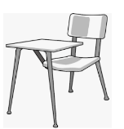 a. Escucha b. Computadora c. Pupitre

D. Write the number word from the word bank next to the correct number.

dos cuatro seis ocho diez uno tres cinco siete nueve

1. ____________________ 6. _______________________

2. ____________________ 7. _______________________

3. ____________________ 8. _______________________

4. ____________________ 9. _______________________

5. ____________________ 10. ______________________

E. Draw a line through the color word with that color crayon, colored pencil or marker.

1. rojo 2. azul 3. negro 4. púrpura