I. The Economic Problem

- Scarcity
  - Human wants are unlimited
  - Means to satisfy them are limited
- Defined- the efficient allocation of the scarce means of production toward the satisfaction of human wants
  - Efficiency
    - Productive efficiency- lowest cost/ best technology
    - Allocative efficiency- amount: MC = MB equilibrium
  - Means of Production
    - Factors of Production… Economic Imports
        - Land- any non-renewable resource (rent)
        - Labor- human element (wages)
        - Capital- tools of production (interest)
        - Entrepreneurship- management (profits)
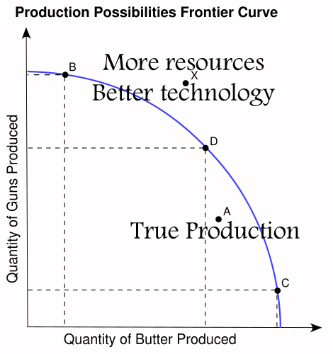
- Production Possibilities Curve
  - Model- illustrates human behavior through mathematics
  - Abstraction- over-simplification
  - Ceteris Paribus → all else equal
  - What does the PPC illustrate?
    - Scarcity
    - Trade-offs
    - Opportunity cost- Value of alternate not chosen
  - Assumptions
      - Full-employment
        - 100% Employment Rate
        - 100% Capacity Utilization Rate
- Productive efficiency
        - Lowest cost
        - Best technology
- Law of Increasing Costs- as you move in one direction along the PPC, opportunity costs increase
  - Factor Suitability- not all resources are equally interchangeable
  - Law of Diminishing marginal returns- as you add additional units of one resource to fixed quantities of the others, marginal returns fall
  - Economies of Scale- as the firm grows, costs fall
  - Diseconomies of Scale- When economies of scale exhaust, diseconomies of scale take over

II. Economic Systems
- Basic Economic Questions
  - What to Produce?
  - How will they be produced?
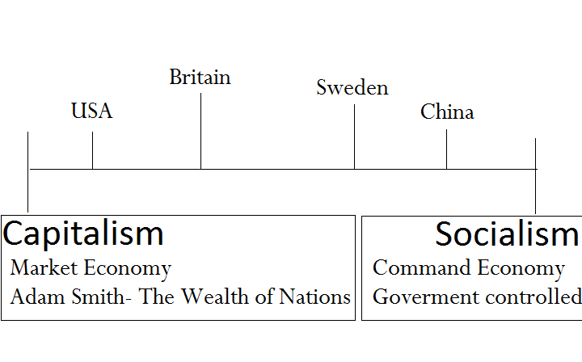
  - How will they be distributed?
  - How will the system accommodate change?
- Mixed Economy- 2 Systems
- How are the questions answered (USA)?
  - What to produce?
    - Private Individuals
- Consumers
- Businesses
  - Firm→ operates plant
  - Industry- number of firms in the same business
~ Firm → Profit = Total Revenue – Total Cost: Accounting Profit
~ Firms and industries will expand when economic profits are realized
~ Consumer → Dollar votes… Consumer Sovereignty
  - How will they be produced?
    - Most efficient use of resources: Lowest Cost → Most profit
    - Roundabout production- the use of capital goods to produce consumer goods
    - Specialization- efficiency
    - Mass production
    - Division of Labor
  - How will it be distributed?
    - Ability to pay
    - Money → medium of exchange – replaces barter double coincidence of wants
- Capitalism → Adam Smith
1776 → Wealth of Nations “Laissez- faire” ~Invisible Hand
1. Profit Motive → “Greed is Good”
- Produce Goods and Services
- Creates Jobs
2. Perfect Competition
- Many sellers, Identical Product
3. Price Mechanism… Supply and Demand!
III. The Public and Private Sector (Chapter 5)
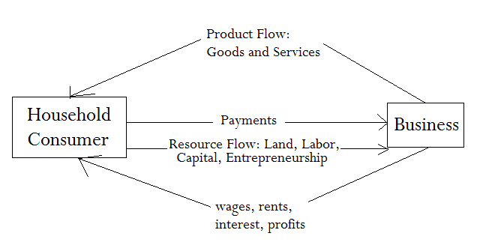
- Circular Flow Model
  - Private Closed Economy→ No government involvement or foreign trade

- Households
-Distribution of Income (Majority comes from wages)
i. Functional Distribution
ii. Personal Distribution
Quintile (1/5)
Top 20% → 60% income
Bottom 20% → 2% income
-What do they buy?
- Durable goods
- Non-durable goods
- Services (Most spent on services today)
- Private Sector
Organization
i. Most common form- Sole Proprietorship
1. One Owner- easy to start!
2. Biggest disadvantage: unlimited liability (financial and legal)
ii. Least Common- Partnership
  - still has unlimited liability
iii. Corporation
Most Productive
500 Corporations produce the majority of output
Most corporations are small businesses
Advantages:
-limited liability “Legal Person”
-sell stocks and bonds
-perpetual life
-transferable ownership
Disadvantage: Double taxation
D. Government’s Role in the Economy
1) American System→ Federal System
Layers of Gov’t…
National Gov’t (D.C.) → States → Local
2) Roles of Government
Provide Public Goods and Services
Legal Structure (Trust)
Regulation- S.E.C.
Promotes Competition
Redistribution of Income
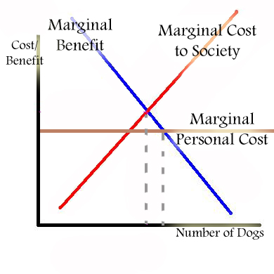
3) Market Failure- Resources are not allocated efficiently
4) Public Goods and Services
- Gov’t must provide because any private sector will not
-Indivisible
-Nonexcludable- free rider problem
- Ex. National Defense, Lighthouse
- Also “Quasi Public” goods
5) Externalities
- Spill-over costs- production imposes a cost on a third party
  - Incentive tax program
  - Command and Control- law-regulation
  - Pollution
- Spill-over benefits- production imposes a benefit on a third party
  - Tax revenues
  - Business benefits
  - Subsidy- government payment to a private firm or individual
Monopoly
- One producer of a good or service
- Tries to reduce output to increase price

Circular Flow Model (Revisited!)
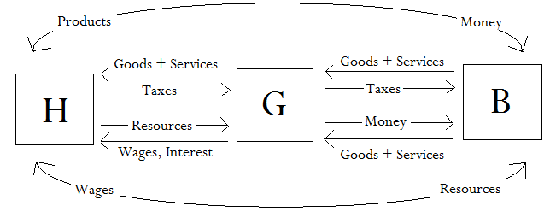
Price Mechanism: Supply + Demand

Theory of Consumer Behavior

Law of Diminishing Marginal Utility- As you acquire additional units of a good or service, marginal utility declines
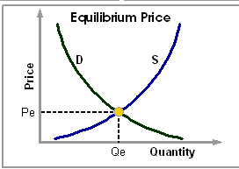
- Demand- the quantity of a good or service people are willing to buy at a given price
- Law of Demand- As the price increases, the quantity demanded decreases (vice versa)
- Demand Schedule (table of Price (Marginal Utility) and Quantity Demanded)

Consumer Surplus- total utility minus the price paid
Substitution Effect- consumers find another product
Income Effect- consumers economize

- Supply Schedule (table of Price (Marginal Utility) and Quantity Demanded)j
- Supply → the quantity of a good or service producers will provide at a given price- dependent on profit
- Law of Supply- As price increases, the quantity (supply) increases (vice versa)

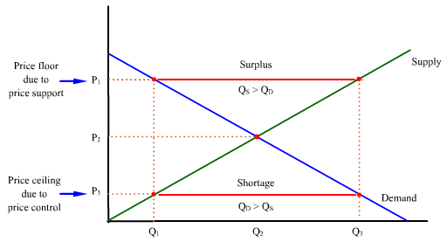
Market Manipulation
  - Price ceiling- gov’t sets the price below market equilibrium
- will hurt the producer
- intends to help the consumer
- creates shortage
- rationing is only way to prevent shortage
- leads to Black markets
  - Price floor- gov’t sets the price above market equilibrium
- Help→ producer
- Hurt→ consumer
- Creates surplus

Changes in Quantity Demanded + Supplied → reaction to a price change

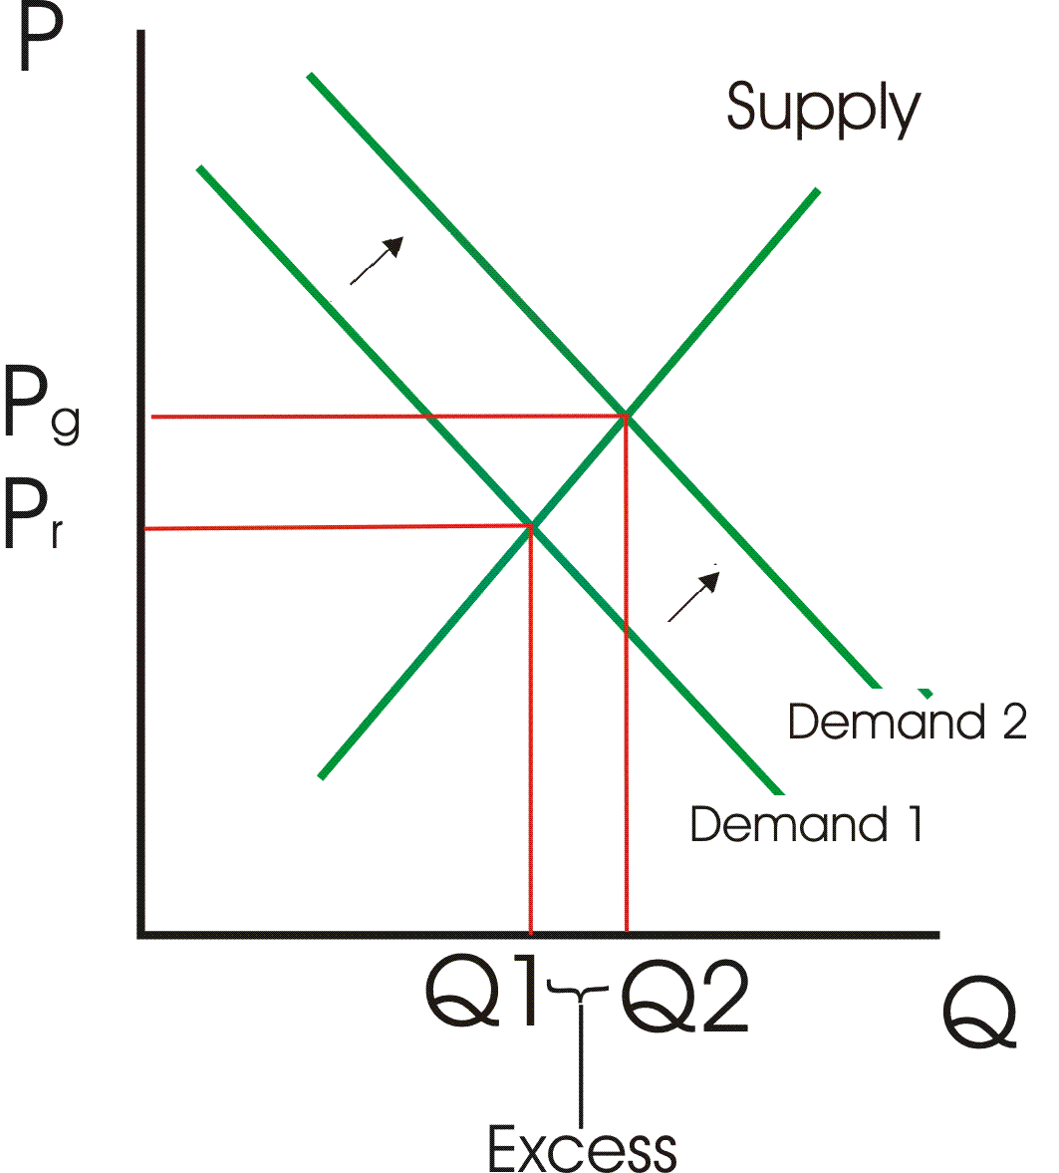
Changes in Supply + Demand
- Increase in Demand→ consumers will buy
more of a product at a set price
- Shift in the demand curve to the right

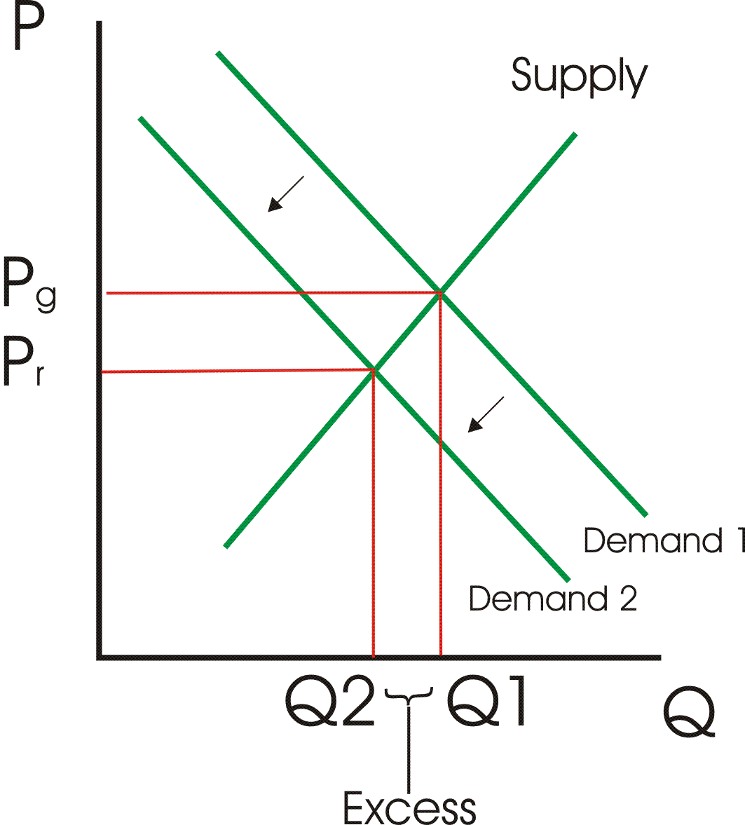

- Decrease in Demand → consumers will buy
less of a product at a set price
- Shift in the demand curve to the left
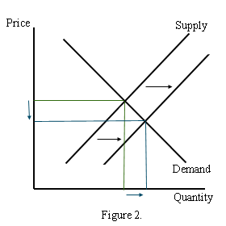
- Increase in Supply → producers will sell
more of a product at a set price
- Shift in supply curve to the right

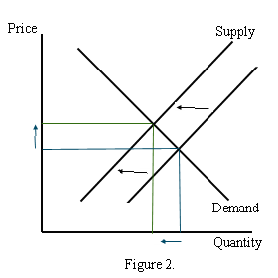
- Decrease in Supply → producers will produce
less of a product at a set price
- Shift in supply curve to the left

E. Determinants of Demand
Taste and Preference
Related Goods and Services
Income * Most important
Buyers
Expectations
- Income
  - Normal goods = as income rises, demand rises
  - Inferior goods = as income falls, demand rises (ex. Used cars)
- Taste and Preference
- Price of Related Goods and Services
  - Substitute Goods- Coke/ Pepsi Poland Spring/ Deer Park
Price of Coke rises, Demand for Pepsi rises
  - Complement Goods
Price of Gas rises, Demand for SUVs fall
- Number of Buyers- more buyers, more demand
- Expectations of Future Prices- if consumers expect the price to decrease, current demand will decrease
F. Determinants of Supply
Resource Prices * Most important
Other Products
Technology
Taxes and Subsidy
Expectations
Number of Sellers

- Resource Prices- As price goes up, supply decreases
- Other Products
  - Joint Products- Price of beef rises, supply of leather will increase
  - Substitute Products- Price of gasoline rises, supply of diesel fuel will fall
- Technology- As technology increases, supply increases
- Taxes and Subsidy- An increase in taxes reduces supply (decrease increases supply)
Subsidy increases supply
- Expectations of Future Prices
- Number of Sellers- More sellers => more supply
III. Elasticity
To what degree do price changes impact the quantity supplied or demanded?

- Demand elasticity
More inelastic demand has a steeper slope…
Perfectly inelastic: E = 0
Perfectly elastic: E = ∞
Inelastic: %ΔQ/%ΔP < 1
Elastic: %ΔQ/%ΔP > 1
- Determinants of elasticity of Demand
  - Proportion of income spend on this good: Greater the proportion→ more elastic
  - Availability of Substitute: More substitutes → Elastic demand
  - Importance of the Good: Greater importance → Inelastic
  - Delay- How long can you put off the purchase: Longer delay → elastic
- Elasticity and Total Revenue
  - Total Revenue = Price x Quantity(sold)
  - If demand is inelastic and price increases, total revenue will increase
  - If demand is elastic and price increases, total revenue will decrease

E < 1 E > 1

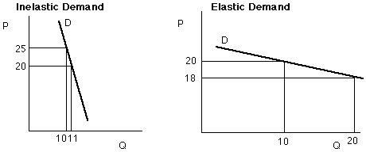

Unit Elastic
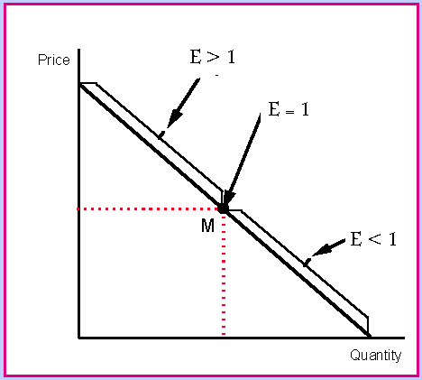

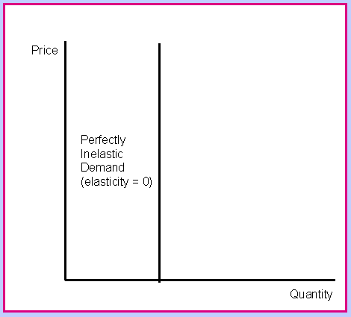
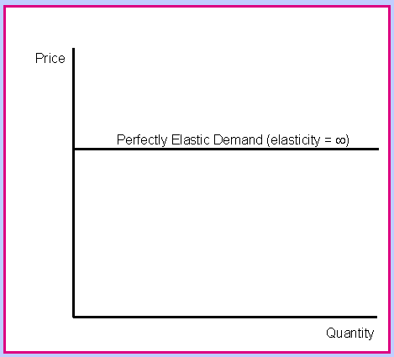

- Elasticity of Supply
  - Math➔ Same as demand
  - Determinants of the elasticity of Supply
    - The Market Period- how long does it takes for a producer to change quantity supplied when the price changes

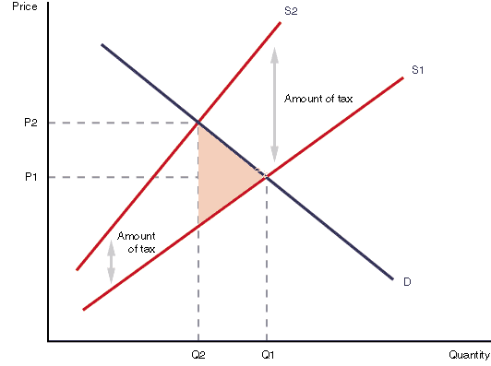

- The Incidence
Tax a product → Excise tax… reduces supply

What is the tax? – vertical distance between supply curves
How much is borne by the consumer?
How much by the producer?
What is the dead weight loss?

Income Elasticity
Normal Good + % Change in Quantity Demanded
Inferior Good - % Change in Income

Cross Price Elasticity
Substitute + % Change in Quantity Demanded of Good X
Complement - % Change in Price of Good Y

- Profit Output/ Production Cost- Short and Long Run
  - Profit
    - Accounting Profit: Total Revenue – Total Costs ← Explicit Costs
Wages, materials, rent, etc.
    - Economic Profit: Accounting Profit – Implicit Costs ← Opportunity Costs
Forgone interest/wages, entrepreneurial skills, capital, etc.
  - Total Marginal and Average Product
    - Productivity- output per unit of input (Land, Labor, Capital, Entrepreneurial Ability)
    - Law of Diminishing Marginal Returns- As a firm adds additional units of one resource to fixed amounts of the others, marginal returns decrease

Units of Labor | Total Product | Marginal Product | Average Product
1 | 5 | 5 | 5
2 | 12 | 7 | 6
3 | 22 | 10 | 7.3
4 | 29 | 7 | 7.25
5 | 35 | 6 | 7
6 | 39 | 4 | 6.5
7 | 42 | 3 | 6
8 | 40 | -2 | 5

Increasing returns to scale

Diminishing returns to scale

Negative returns to scale

  - Costs
    - Total Cost- cost to produce a good or service
    - Total Cost = Fixed cost + Variable cost
    - Fixed Costs → do not change with the number of units produced:
ex. Building, equipment, etc.
    - Variable (direct) Costs → do change with the number of units produced:
ex. Disposable items, hourly wages
  - Short-run and Long-run
    - Short-run → period of fixed plant size – fixed costs remain fixed
    - Short run options
      - Operate at a profit: TR > TC
      - Operate at a loss: TC > TR >VC
      - Shut down: TR < VC
    - Long-run → all costs become variable- Stay in business? Expand or contract?
    - Long-run options
      - Stay in business
      - Go out of business

  - Short-run Cost Schedule
Output | VC | TC | AFC | AVC | ATC | MC
1 | $100 | $500 | $400 | $100 | $500 | $100
2 | $150 | $550 | $200 | $75 | $275 | $50
3 | $210 | $610 | $133 | $70 | $203 | $60
4 | $300 | $700 | $100 | $75 | $175 | $90
5 | $430 | $830 | $80 | $86 | $166 | $130
6 | $600 | $1000 | $67 | $100 | $167 | $170
7 | $819 | $1219 | $57 | $107 | $174 | $219

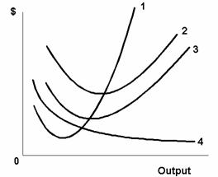

1: Marginal Cost
2: Average Total Cost
3: Average Variable Cost

          - AVC and ATC must intersect
MC at their minimum

  - Shift in the Cost Curves
If variable costs fall, all curves (MC, ATC, and AVC) fall
If fixed costs rise, only the ATC curve rises

  - Long-run Cost Curves
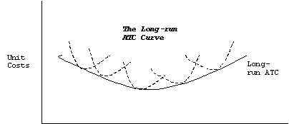

Economy of Scale- Falling average costs as the firm expands (buy in bulk, specialization, etc.)
Diseconomies of Scale- Increasing average costs as the firm expands

Decreasing, Constant, and Increasing Cost industries…

- Chapter 23 → Perfect Competition
  - Competitive Spectrum
Perfect Competition – many sellers
Monopolistic Competition- Product differentiation, many sellers
Oligopoly- few sellers
Monopoly- single seller

  - Conditions for Perfect Competition
    - Many sellers “Price Takers” → No one producer controls enough of the product to influence the price
    - Identical Product
    - No barriers to entry- Perfect mobility
    - Perfect Knowledge- no secrets

Marginal Revenue Curve- the additional revenue gained by the sale of one more unit = the firm’s Demand Curve
* A firm will maximize profit or minimize loss by producing where MR = MC
  - Perfect Competition in the Short and Long Run
    - Short run- perfect competition
May break-even or make an economic profit
Normal profit = minimum of the ATC
Firm will operate at a loss or shut down
    - Long run- will always break even

- Monopoly
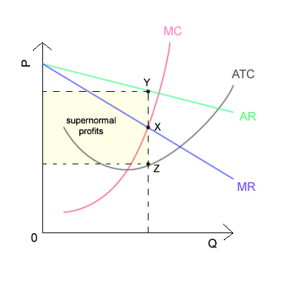
  - Conditions
    - One seller → Price maker, produces all the output
    - Product- doesn’t matter
    - Entry is restricted
    - Very restricted knowledge
  - The Graph of the Monopoly
    - Monopolist’s Demand Curve is the
Industry Demand Curve
    - Marginal Revenue
Price | Quantity | Total  Revenue | Marginal  Revenue
9 | 1 | 9 | 9
8 | 2 | 16 | 7
7 | 3 | 21 | 5
6 | 4 | 24 | 3
5 | 5 | 25 | 1

-For the perfect competitor MR= D. They can sell all output at the Industry Price. MR = Price of each additional unit sold.
- For the monopolist, their demand curve is the industry demand curve. They must lower price to sell additional output → when they do the price is lowered and all units sold- MR will fall faster than demand

  - Monopoly in the Short and Long Run
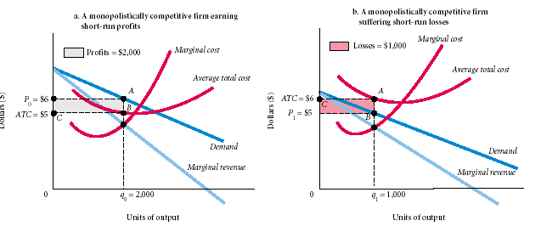
  - if the monopoly is making an economic profit, there is NO distinction
  - if the monopoly is taking a loss, it must be in the short run

  - Barriers to Entry
    - Exclusive control over an essential resource
De Beers
    - Economies of Scale
“Minimum efficiency of scale”
Lowest cost
    - Legal Barriers
      - Patent – 17 years: Incentive to innovate
      - Copyright
      - Franchise
    - Natural Monopoly-must be a monopoly to provide the good or service at lowest cost
Ex. utilities
    - Economics of Being Established
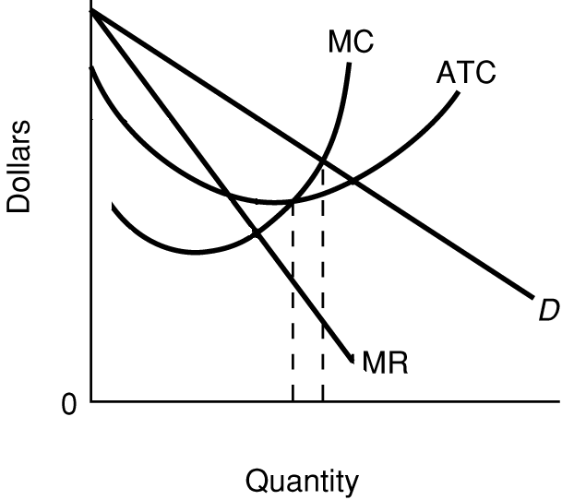
  - Economic Problem of Monopoly Market Failure
    - Productive Efficiency
      - Minimum of ATC
      - Will not be Productively Efficient
    - Allocative Efficiency
      - MC = MB
      - S = D
      - Socially optimal level of output

  - Policy Options
    - Do nothing → Subsitutes- innovation
    - Break them up
    - Nationalize- Government takes them over
    - Regulation
      - FRT- Fare Rate of Return Module → min. ATC
      - Subsidy

  - Price Discrimination- charges different prices for the same good or service
    - Market Power- Monopoly Power
Lerner Index = (P – MC)/P
    - Segregate Buyers
    - Prevent Resale

- Monopolistic Competition
  - Conditions
    - Sellers→ many
    - Barriers to entry- few
    - Secrets to knowledge – little
    - Products – similar
Differentiate→
advertising, packaging, convenience
  - Short and Long Run
    - Short Run…
Economic Profits
Operate at a Loss
Shut down
    - Long run- Break Even!
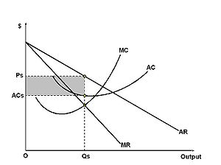
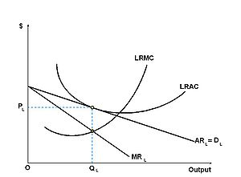
Short-Run Long-Run

- Oligopoly
  - Conditions
    - Few Sellers → Any one controls output to influence price
    - Product-
      - Pure Oligopoly- identical product→ do not generally advertise
      - Differentiated- similar product
“non-price competition”
    - Many Barriers*
    - Many Secrets* Economic profits!
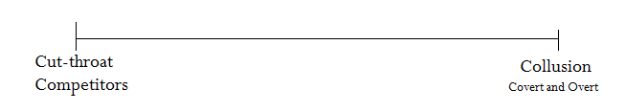
  - Competitive Spectrum

    - Concentration Ratio- % of market share of top 4 producers
    - Hershman-Herfendahl Index- Sum of Squares of the market shares of all the firms in the industry
  - How is price or output established in the oligopoly?
    - Game Theory
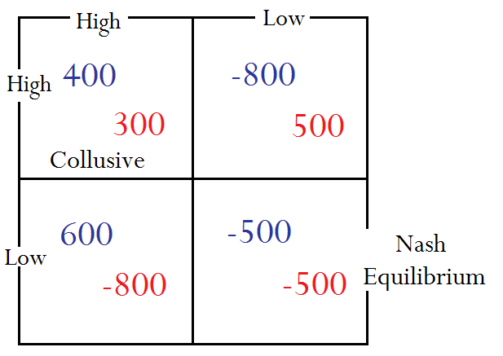
Duopoly-2 firms

    - Kinked Demand Curve Theory
      - Sticky Price- Price Leadership
      - Elastic-demand→ Increase in firm’s price→ competitors will not follow
Total Revenue will fall
      - Inelastic-demand→ lower your price… all firms will follow→ Price War
Total Revenue will fall
- Corporate Mergers and Anti-Trust
  - Types of Mergers- two or more businesses join to form one
Obtain a greater market share
    - Most common- conventional merger:
Horizontal merger- firm merges with its competition
    - Vertical Merger- producer merges with its supplier
    - Conglomerate Merger- 2 firms in completely different industries merge
  - History of Anti-Trust
Trust Directorate
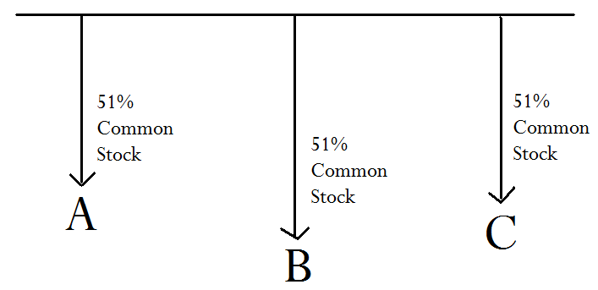
Standard Oil of Ohio

1) Sherman Anti-Trust Act 1890
Key passage → Conspiracy to restrict trade
First applied to Unions
1911→ Standard Oil Case
established→ Rule of Reason “Big + Bad”
1920→ U.S. Steel
acquitted→ solidified the rule of reason
1930→ Alcoa Cases
2) Clayton Anti-Trust Act 1914
a. Banned Interlocking Stockholding
b. Interlocking Directorates
c. Price discrimination (Predatory Pricing)
d. Exclusive Dealings
e. Tying Contract
3) Federal Trade Commission (FTC) Act –1914

I. The Factor Market
*Factors of Production
Land-rent
Labor-wages
Capital-interest
A. Marginal Productivity Theory
1) A firm will hire additional units of a resource until the MRP of the last unit equals its price
B. Derived Demand- the demand for all economic resources is derived from the demand for the finished product
Units of Labor | Output | MP | Price | TRP | MRP
1 | 7 | 7 | $2 | 14 | 14
2 | 13 | 6 | $2 | 26 | 12
3 | 18 | 5 | $2 | 36 | 10
4 | 22 | 4 | $2 | 44 | 8
5 | 25 | 3 | $2 | 50 | 6
6 | 27 | 2 | $2 | 54 | 4
7 | 28 | 1 | $2 | 56 | 2

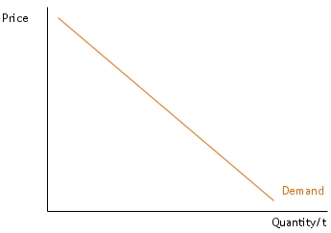
Law of Demand
MRP

C. Determinants of Resource Demand
1) Derived Demand → demand for finished product increases, the demand for resources used in its production increases
2) Productivity → Unit of output per unit of input
increase in productivity → increase in MRP
decrease in productivity → decrease in MRP
3) Prices of other resources
-Substitute resources
price of capital increases → hire more labor
(substitution effect)
*Output effect
If the price of a resource increases, the demand for other resources falls
-Complements- If a firm purchases more capital (trucks) then the demand for labor would increase
4) Quantity of other resources
D. The Elasticity of the Economic resources deals mostly with how easily they can be substituted.

II. Labor and Wages
A. Terms
1. Income Disparity and Wage Differential
Human Capital
Jeff Lamb → → Payton Manning
$7.60 23 million
2. Nominal Wage – current dollar value wage
3. Real Wage- what the wage can buy
- can only be increased by increases productivity
B. Labor Market Theories
1. Non-competing Group
-unskilled
-skilled worker
-professional
2. Non-homogeneous jobs
-pay more for dirty work
-get the subjugated people to do it
3. Dual Labor Market Theory
Primary market → middle class Job-security, advancement
--------------------------------------------------------------------------> College degree
Secondary market → low-pay little security

C. Backward Bending Supply Curve for Labor

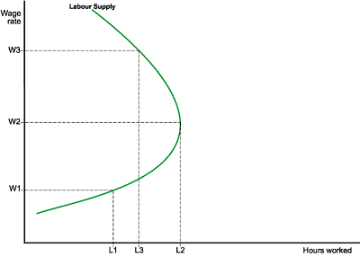
Substitution Effect→ give up time for money

D. Labor Market Models
Hire until MRP = MRC
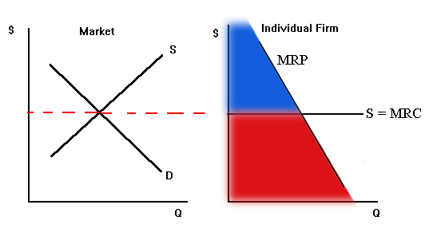
1. Perfectly Competitive Labor Market- firm can hire all the labor it needs at the market wage→ minimum wage

Non-wage costs Total wage bill Total revenue

2. Monopsony- firm hires enough of the labor to influence wage eg. NFL, nurse, teacher
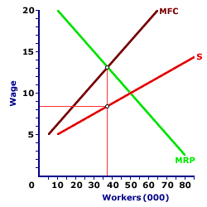

3. Bilateral Monopoly- monopsony with labor unions
- wage will be between monopsony and going market wage
-Collective Bargaining Process
How do Unions operate?
- better wages, benefits, working conditions

E. Union Models
1. Labor Enhancement Model
-increase productivity
-work rules
2. Craft Union Model eg. AFL
3. Industrial (Inclusive) Model eg. UMW, UAW

Closed Shop- must be in union to work there

Principal-Agent Problem- Pay for Performance
Merit Pay
Commission, Incentives
Piece work—pay by units of finished product

III. Land and Rent
Any non-renewable natural resource
Rent → price paid for land
Henry George- single-tax

A. Supply of Land
B. Rent is determined by the MRP of the highest bidder
*Productivity
*Location
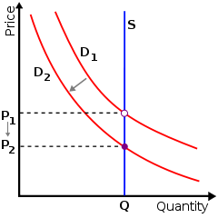

IV. Capital and Interest
Capital-(must have savings) tools of production, cannot exist in subsistence environment
Capital is a stock
Investment is a flow
Usury laws set the ceiling on interest rates
Banks→ take savings and use to invest
Interest→ price paid for the use of capital

A. Loanable Funds Theory of Interest Rates
Supply and Demand of Funds
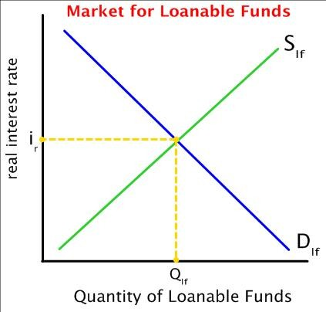

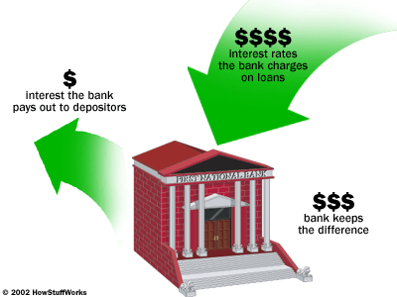
B. Elements of the Contractual Interest Rate
* Pure/base rate- rate paid by government on the long bond
* Risk Premium
-Default
-Inflation
* Service Charge

C. How is the Rate of Interest Determined?
Interest rate up
More loanable funds
People save more (harder to finance autos/mortgages at high interest rates)
Less spending

V. Income Inequality and Taxation

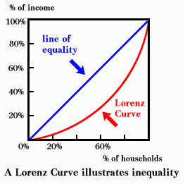

Quintile Concept- wealth skewed to 5th quintile

Line of Perfect Equality- every quintile owns 20% of income- Communist utopia

Gini ratio- extent to which the curve bows out

The more bowed out the curve, the greater income inequality

Disparity represented by the area between line and curve

Poverty
-Absolute Poverty→ Poverty Line $23,000 USDA→ food stamps
-Relative Poverty→ it depends
Why?
-do not have productive services to sell
-lack of Human Capital
Poverty Programs- TANF, Medicaid, etc.

Economies of Taxation

Who should pay?
*Benefits-received principle
by those who benefit from the government’s services
FICA→ social security up to 90,000
*Ability to Pay→ rich should pay more
Federal Income Tax
What should be taxed?
*Indirect taxes
- to tax goods or services
Excise taxes- gas
Tariffs
* 1913 Direct Tax
16th Amendment→ tax on a person’s income
Who bears the burden?
1) Progressive- as income increases, the percent tax increases (series of marginal tax rates)
Federal Income Tax
2) Proportional tax- all pay the same percent of income “flat tax”
3) Regressive- lower your income, the greater percent of income taxed
Social Security, gas, sales taxes

Macro Economics

I. International Trade
A. Theory of Trade→ make the case for “free trade”- no barriers
David Riccardo→ Law of Comparative Advantage- a nation will benefit most by producing those goods and services it produces with the lowest opportunity cost
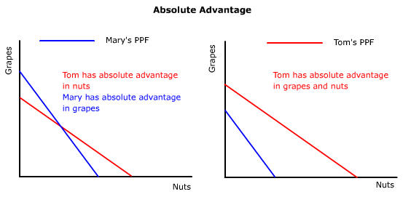

*Domestic Equation of Exchange- Ratio of the PPC for a nation, eg. Grapes: Nuts
*Specialization

B. The Practice of International Trade
1) Balance of Trade
Trade Surplus: Exports > Imports U.S. 1946-1975
Trade Deficit: Exports < Imports U.S. 1975—
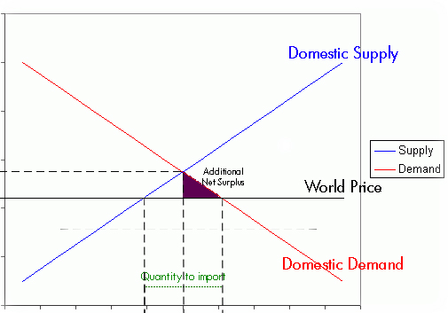

OIL

2) What if free trade is not fair trade?
WTO- World Trade Organization
GATT Treaty

Dumping→ sell a product in a foreign market below cost- requires a subsidy
3) Protections
*Tariff
1998- Bill Clinton- tariff on luxury cars
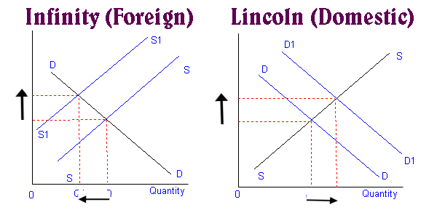

*Quota- limit on the number of items imported
- less efficient than tariff because it decreases efficiency

4) Non-Tariff Barriers
*Subsidy
*Health-Safety Regulations

C. Arguments for Protection
      - National Security *- most convincing
      - Low Wages
      - Employment
      - Infant Industry

II. International Finance
*International Trade is one part of international finance
A. Balance of Payments
Current Account Capital Account
Payments for Goods and Services Payments for Investment
Transfers
- Merchandise Trade Exports + -Stock
- Merchandise Trade Imports – -Bonds
- Service Exports + -Real Estate
- Service Imports –
- Incoming Transfers +
- Outgoing Transfers –
0 = 0
B. Exchange Rates
$1 = 90 ¥
$1 = .77 €
1) Falling Dollar
$1 = 85 ¥
$1 = .65 €
-US Imports → decrease
-US Exports → increase
2) Rising Dollar
$1 = 100 ¥
$1 = .90 €
-US Imports → increase
-US Exports → decrease
3) Gold Standard
*Currency could be redeemed for gold at a fixed rate
*Prior to 1933
David Hume

Country A Country Q
→ Exports 200 Billion
← Exports 100 Billion
← 100 Billion Gold

C. Floating Exchange Rates

Yen per Dollar
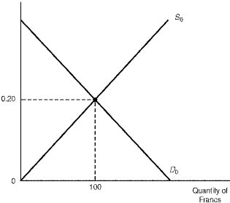
1) Supply of U.S. Dollars to Japan
-buy Japanese goods and services
-invest in Japanese assets

2) Demand for US Dollars in Japan
-buy US goods and services
-invest in US assets

3) Determinants of Exchange Rates
Prices- price level in each country
-Prices in Japan are lower than those in the US
Supply of Dollars increases
Interest Rates
-Interest rates are higher in the US than in Japan
Demand for Dollars increases
Economic Growth - GDP
Quantity of Dollars
-The US economy is growing faster than Japan
Indeterminate

I. Chapter 7--> GDP

A. What is the GDP?
1) Gross Domestic Product-
total dollar value of all goods and services produced in a nation in one year – 13.5 Trillion
BLS – Bureau of Labor statistics –
Simon Kuznats- national income 1929- 1932
Circular Flow Model
Great Depression- GDP fell by 50%
2) What is measured ?
Finished Products- avoid double counting
Must be produced in the current year
Money must be exchanged
3) What is not measured?
Resold
Barter
financial transactions
govt. transfer payments – social security
private transfer payments
stocks, bonds,
illegal activities
domestic work


B. Terms to Know

Personal consumption expenditures-
all the money spent by consumers
on new/finished products

Net foreign factor income-
difference between investment
overseas and overseas investment

Transfer payments- paid out to
individuals by the govt.

Rents- price paid for the use of land

Consumption of fixed products
depreciation- plant and equipment
worn out in the production process

Social security contributions- goes to government

Interest- money for capital

Proprietor's income- profit to
businesses that are proprietorships

Net exports Personal Savings

Dividends- distributed corporate
profits- payment received per
share of stock owned

Compensation of employees- wages

Indirect business tax- taxes on products, sales taxes, gas taxes

Undistributed corporate profits- no dividends, keep money on-hand

Personal taxes-paid by individuals

Corporate income taxes

Corporate profits

Government purchases

Net private domestic investment- Gross Private, Domestic Investment – Consumption of Fixed Assets (Depreciation)

C. Calculating GDP
1. Expenditures Approach
GDP = C + I + G + X_{n}
C→Consumption Expenditures 2/3 of total economy
I→ Gross Investment:
Net Private Domestic Investment + Consumption of Fixed Assets (Depreciation)
G→ Government Purchases
X_{n}→ Net Exports: Exports – Imports
2. Flow of Income Approach
NI→ National Income- the payments to the factors of production
76% labor-wages
land- rent
capital- interest
entrepreneurship- profit
NNP → Net National Product = NI + Indirect Business Taxes
(NDP → NNP + Net Foreign Factor Income)
GDP → NNP + Consumption of Fixed Assets + Net Foreign Factor Income
3. Other Measures
PI→ Personal Income- before tax income of individuals
PI = NI – (Corporate Income Tax + Undistributed Corporate Profit + Payroll taxes)
+ Transfer Payments
DI→ Disposable Income- after tax income of individuals
DI = PI – Personal Taxes

PS→ Personal Savings
PS = DI – Personal Consumption Expenditures

D. Other Measures of GDP
1. International Comparisons
Per Capita GDP= GDP / Population

2. Real GDP→ GDP adjusted for inflation – need for economic growth
Money GDP, Nominal GDP, Current GDP
Measured in current dollar value

GDP inflator is not weighted
Money GDP x GDP Deflator Base Year
GDP Deflator Current Year

II. Chapter 8 → Economic Instability
Recession: 2 consecutive quarter decline in real GDP
Unemployment: 7.6% Feb 2009
25% Dec 1932
Inflation:
Stagflation: combination of inflation and unemployment

A. The Business Cycle
Differs in amplitude and duration
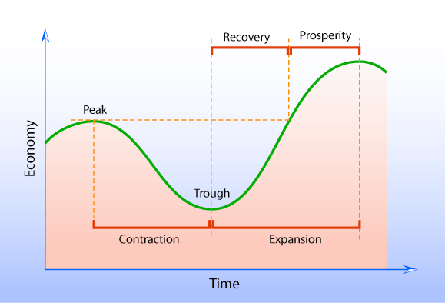

Okun’s Law
Concrete relationship between business cycle and unemployment
Current Real GDP

B. Unemployment
1. Unemployment Rate
Number of Unemployed
Labor Force
2. The Natural Rate of Unemployment- 5%
-Frictional Unemployment (in between jobs)
-Structural Unemployment (skills become obsolete, technology advances)
-Seasonal
3. Cyclical Unemployment > 5%
due to reduction in GDP
4. Opinions on the unemployment rate
Liberal- underestimates unemployment, does not account for:
discouraged workers and underemployed
Conservative- overestimates unemployment, frictional should not be included

C. Inflation
1. General rise in price level
2. Measured by the CPI- Consumer Price Index
Calculated using the prices of a market basket of goods and services
Weighted- some items are counted more
Computed using a base year- CPI = 100% 1985
Rate of Inflation = 2% 102% 1986

CPI | Year
100% | 2001
101% | 2002
103% | 2003
106% | 2004
110% | 2005
111% | 2006
109% | 2007

Inflation

Disinflation
Deflation

3. When is inflation a problem?
When it is unexpected
Hyperinflation- Germany 1920’s: 23,000%
D. Causes of Inflation
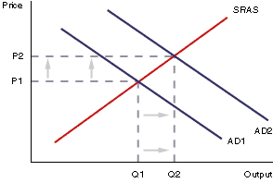
1. Demand-Pull Inflation

Too many dollars chasing too few goods during times of war

2. Cost Push Inflation – stagflation
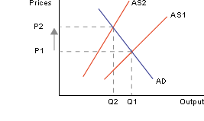
Cost of production rises, supply falls

Supply Shock- prices of an essential resource

Wage price spiral

E. Who is hurt by unexpected inflation?
1. Lenders
Real interest rate = Nominal Interest Rate – Inflation Rate
2. Fixed Income-
Old Age Pension
3. Wage Earner
4. Business

III. Macroeconomics Relationships
A. John Maynard Keynes
1932—General Theory of Employment- interest and money

1. As disposable income increases, comsumption increases but not as quickly
2. Savings function- As disposable income rises, savings rise but not as quickly
3. APC Average Propensity to Consume
APC = Consumption / DI DI = Disposable Income
APS Average Propensity to Save
APS = Savings / DI
4. MPC Marginal Propensity to Consume-
what proportion of each additional dollar obtained will be spent
MPC = ΔC / Δ DI
MPS = ΔS / Δ DI MPC + MPS = 1

B. Graphing the Consumption Function

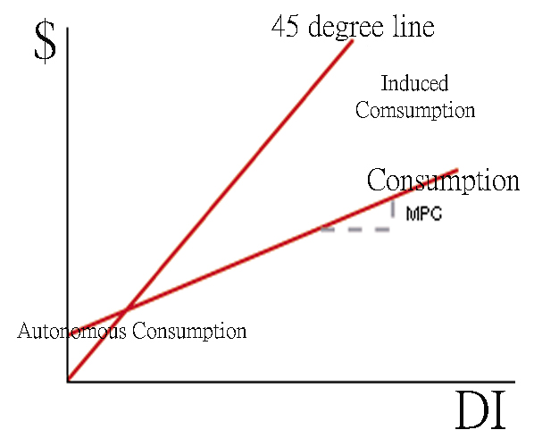

APC = C = DI – S
. DI DI

APS = S = DI – C
. DI DI

MPC = ΔC
Δ DI

C. The Multiplier- any new spending in an economy will increase the GDP by a rate of spending x m
m = 1 / (1- MPC)

D. Non-income determinants of consumption
1. Wealth-value of Assets in the hands of consumers- homes/stocks
2. Credit Availability (Level of Interest Rates)
3. Consumer Debt
4. State of Durable Goods in the hands of consumers
5. Taxes
E. The Investment Demand Curve
*Investment is less stable than consumption
C + I + G + Xn = GDP
*Keynes-Investment will only take place if the expected rate of return is greater than the current real rate of interest

Car Wash
$200,000 – savings or loan
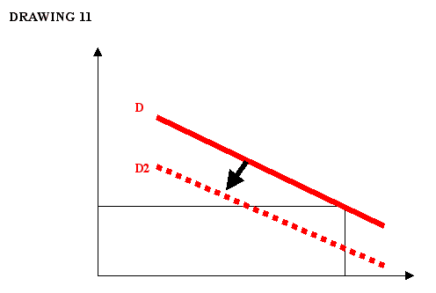
1 Year returns - $20,000
Rate of Interest: 10% Income/ Capital Cost

Real Rate of Interest

Quantity of Investment
Determinants of Investment
1. Sales outlook (expectations)
2. Capacity Utilization Rate
% of plant and equipment current employed- 85%
3. Technology
4. Taxes

I. Aggregate Expenditures Model (Keynesian Cross)
Aggregate Expenditure- total spending in the economy
AE = C + I + G + X_{n}
Equilibrium GDP→ All output is purchased
Full-employment GDP

-AE-consumption (certain amount to spend in order to obtain specific GDP)
-Slope of AE determined by Consumption since only C varies with GDP; others constant

If people save, they are not buying all available output (leftover inventory)
However, banks lend money to businesses, who in turn spend that money

Equilibrium GDP
-all income spent
-everything produced is consumed
-supply=demand
-taxes=govt. spending
-natural--economy will always shift back
-may be below full or potential employment

Circular Flow
Households send $ -> businesses
Businesses send Goods/Services -> Households

Full-Employment GDP-Level of GDP at which ALL resources are employed; no unemployment; analogous to potential GDP
-Ideal
-No GDP gaps; prosperity (must resist the recession state, etc. of business cycle)
-Keynes debate: he believed it was an unnatural state of the economy
-Leakages (Savings, Taxes, Imports; GDP > AE) = Injections (Investment, Government Spending, Exports; GDP < AE)
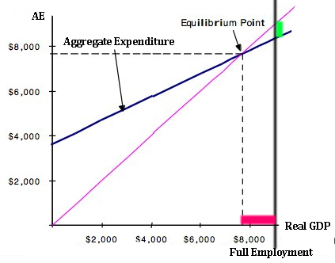
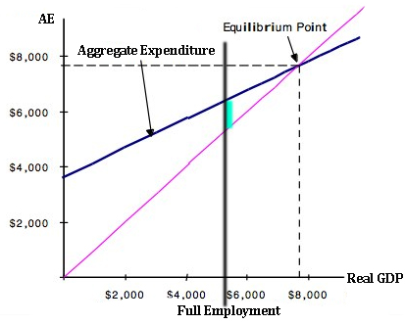

Recessionary/Deflationary Gap Inflationary Gap
GDP Gap

Multiplier = GDP Gap .
Recessionary Gap
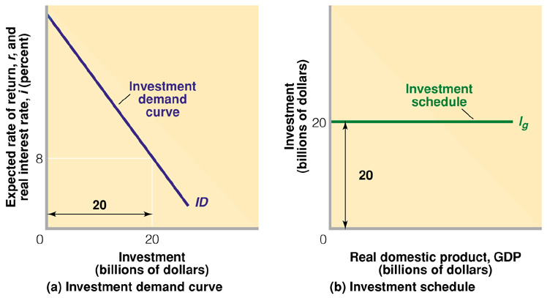
-Investment demand curve (downward slope; investment varying according to i.r.)

Investment Schedule-how much businesses will plan to invest at a particular interest rate; it is a fixed amount of investment that stays same regardless of level of GDP; PLANNED (slope is zero; horizontal line ie at 7% ir, x will be invested and will not change)
-this is reason why consumption and consumption + investment lines are parallel
-unplanned investment leads to disequilibrium

Consumption is heart of macro; all else relatively stable
Demand-pull INFLATION
-occurs when actual GDP exceeds potential GDP/full employment
Solutions:
-increase taxes
-reduce government spending
-need a surplus

Political Dilemma:
Is this perfect solution to business cycle?
Government Policy reflects conflicting interests
When times are good, inflation is a problem, but government is reluctant to remedy it by cutting spending and raising taxes.
-gov may spend independent of GDP

Recession (Deflation)
Solution: Increase Consumption of Government by spending money or Decrease Taxes (Obama's stimulus policy bill)
-Arguably, gov. is best candidate to increase C because people tend to save money or pay debt instead of spending all their money)

Multiplier: For every dollar government spends, GDP goes up by this factor.

II. Aggregate Supply and Demand
- Aggregate Demand→ quantity of GDP demanded at a certain price level→ CPI
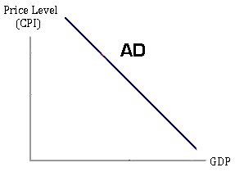
AD = C + I + G + Xn

1. Real Balance Effect- Wealth Effect
As the price level rises, people will purchase less because they feel poor.
As the price level falls, people will purchase more because they feel richer.

2. Interest Rate Effect
As prices rise- interest rates increase
Savings increase / Consumption falls

3. Foreign Purchases Effect
As the price level rises, we buy more imports→ GDP falls
As the price level falls, we buy less imports→ GDP rises

- Aggregate Supply- Level of output at a certain price level
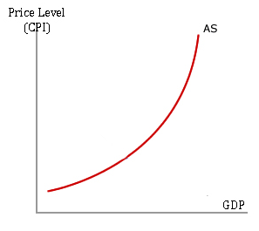

1. Short-run Aggregate Supply
*Fixed Costs
2. Long-run Aggregate Supply
at full employment

- Equilibrium GDP
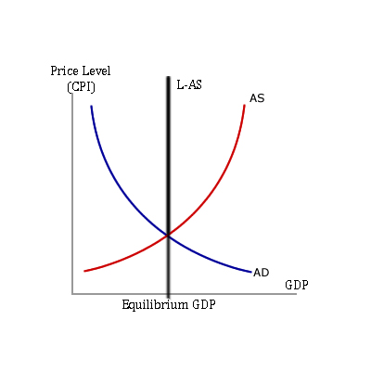

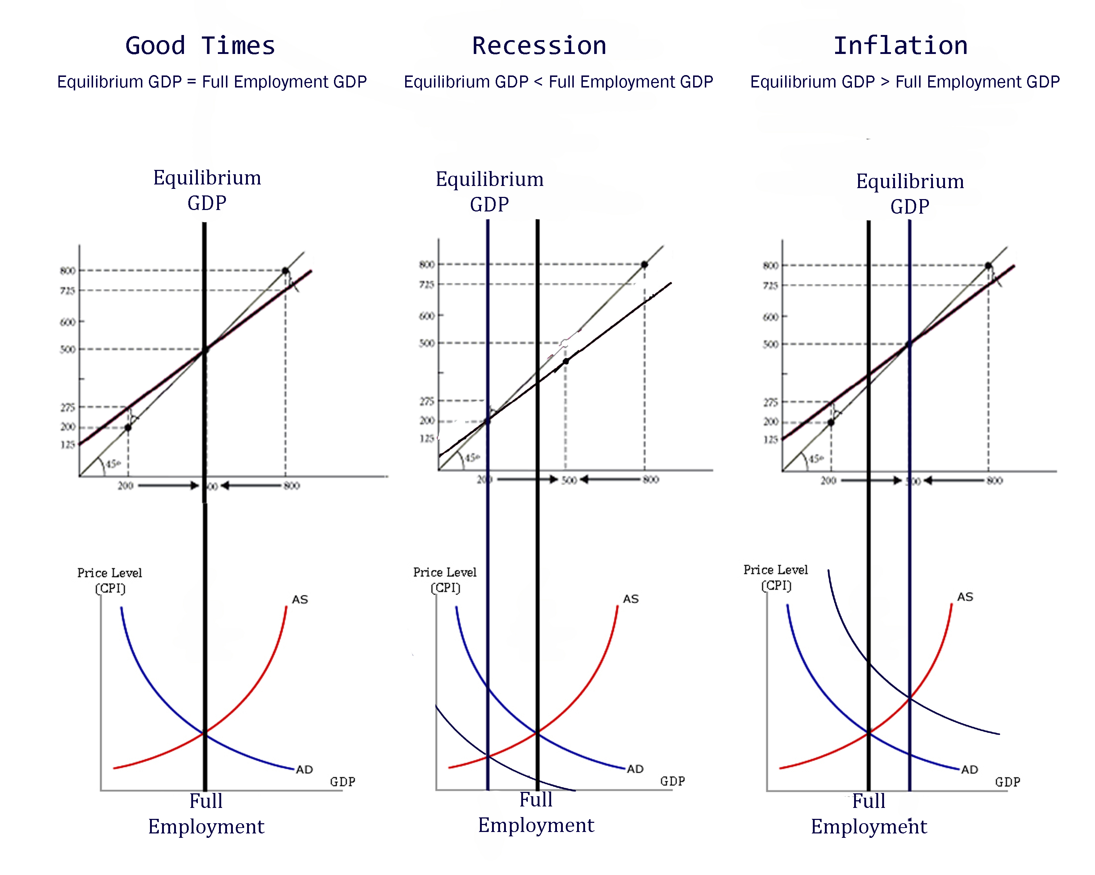

- Determinants of Aggregate Demand
If AD increases (shifts to the right)
1. Consumption increases
Expectation of Inflation
Increase Income or Wealth
Optimism about jobs or growth
2. Investment increases
Lower Interest Rates
3. Government Spending increases
4. Xn increases
Net exports increase
Value of the dollar falls
Foreign imports decrease

- Changes in Short-run Aggregate Supply
1. Costs input prices- land, labor, capital, entrepreneurial ability
2. Changes in Productivity- unit of output per unit of input
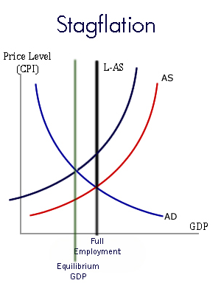
3. Legal institutional environment
Tax/ Subsidies
Government Regulation

III. Fiscal Policy
- Government Policy of Taxing and Spending to Influence the Economy (1930’s)
  - Employment Act of 1946- Council of Economic Advisors
Wrote Keynesian economics
Promote full employment and stable prices and economic growth
Today → Stimulus package
Huge Spending and Tax Cuts to fight Recession
  - Who makes fiscal policy?
President and Congress make laws
State and local governments
- Discretionary Fiscal Policy
  - Expansionary Fiscal Policy
Fight Recession/Unemployment
-Increase Government Spending
-Reduce Taxes
  - Contractionary Fiscal Policy
Fight Inflation
-Reduce Government Spending
-Increase Taxes

Government Spending Multiplier
1 = GDP ,
1-MPC Recessionary Gap
Tax Cut Multiplier
MPC Less than the government spending multiplier
MPS

- Automatic Stabilizers
(Non-discretionary Fiscal Policy)

-Savings: Good Times, More Savings
"help you spend" during bad times

Recession
Automatically put money into the economy
-Progressive Income Tax
-Unemployment→income falls →
% tax falls
-Unemployment Compensation
-Maintains spending during a recession

Inflation
Automatically takes money out of the economy
-Progressive Income Tax
-Unemployment falls→income increases → % tax increases

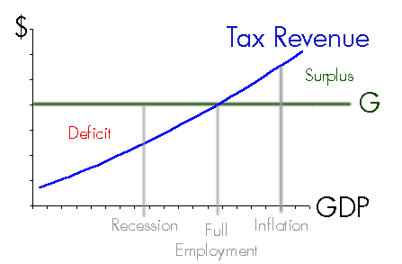
- How well does Fiscal Policy work?
1. Full-employment Balanced Budget
Recession- Expansionary Fiscal Policy
Increase spending, decrease taxes

2. Timing- by the time the fiscal policy is enacted, the problem has changed
*Recognition Lag
*Administration Lag
*Implementation/ Operational Lag
3. State and Local Fiscal Dilemma
*Must have balanced budget
4. Crowding Out→ Government spending crowds out private investment
-Deficit→ $1.6 trillion
-Treasury→ Sell bonds
-increase interest rates
-business must pay higher interest rates

5. Foreign Effect

Recession
Expansionary Fiscal Policy
Deficit Increases
Increased Interest Rates
International Value of the $ increases
Imports Increase
Exports Decrease
GDP Decreases

Inflation
Contractionary Fiscal Policy
Deficit Decreases
Interest Rates Decrease
International Value of $ decreases
Imports Decrease
Exports Increase
GDP Increases

Keynes argued deficit was inevitable; good in sense that money was left in people's pockets to spend

Federal income tax largest source of govt. revenue
Remember: government spending and planned invest. independent of GDP level

Controversy of Government: People want more government programs AND lowered taxes; defeat the other in its effect

Hoover: During recession, he eliminated deficit to balance the budget-like pouring salt on a wound.

Money, Banking, Monetary Policy
- Purpose of Money
  - Medium of exchange
    - Replaced → Barter
      - Double coincidence of wants
    - U.S. Dollar
      - Fiat Money
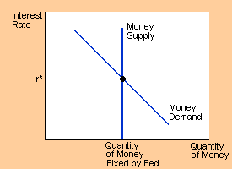
      - Legal Tender
      - Elastic Currency
      - Value is a function of what it can buy.
  - Standard of Value
    - Understanding of an object's value
  - Store of Value
    - Can be “stored” purely as its value
    - Weakest purpose due to inflation
  - Standard of deferred payment
    - Make contract
- Money Market
  - Money Supply
    - Components
      - M1: Currency + Checkable Deposits
      - M2: M1 + Savings, Money Markets, Small-Denomination Time Deposits¹
      - M3: M2 + Large Denomination Time Deposits²
1Small Denomination Time Deposits: Something like a CD (certificate of deposit). Small denotes a value less than $100,000
2Large Denomination Time Deposits: A time deposit larger than $100,000
    - Manipulated by Federal Reserve loans.
      - Loans increase money supply
      - Payback on loans decrease money supply
  - Demand for Money
    - Holding money balances.
    - Motives for holding money balances – Keynes
      - Transaction Motive: To pay one's bills.
        - Vertical demand; fixed, with no change in regards to interest rate.
      - Precautionary Motive: Insurance for unexpected changes (rainy day cash).
        - Slightly more elastic; interest rate can influence fear of problems.
      - Speculative Motive: Preparation for fiscal opportunities.
        - Relatively elastic. Changes in interest rate influence what this money is used for.
    - Changes in demand for money balances
      - Income
        - Higher income, higher demand for money.

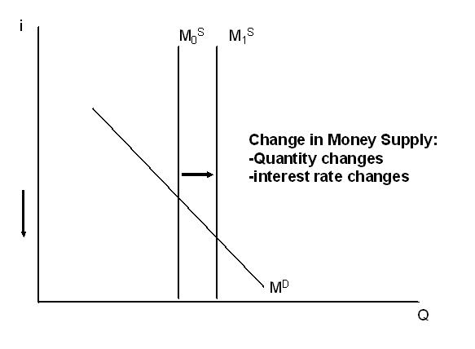
- The Bond Market
  - Bond: Acknowledgement of Debt
    - Face Value – Principal
      - Example: $100
    - Interest Rate
      - Example: 5% APR→ Pay $5.00
        - APR: Annual Percentage Rate
    - Duration / Maturation Period
      - Example: 1 year, 30 year
  - Bond Yield: Investor's return on investment in a bond
Example:
    - Bonds will tend to be sold at prices that produce yields near the going interest rate.
    - If Bond Price increases, yield decreases, and vice versa.
- The Federal Reserve
  - National Bank
  - Gold Smiths :: A STORY FOR THE AGES!
    - Made gold into gold coins
    - Gold King gave gold to Gold Smith
    - Gold Smith gave “IOU” for gold coins to Gold King
    - Another King betroths daughter to Gold King. Gold King gives an “IOU” for the dowry to Other King, referencing the location of his gold coins with the Gold Smith.
    - Gold Smith is smart, begins “producing” “IOUs,” paper money, and receiving interest on loaning out the money; fractional reserve banking.
    - Panic of 1907:
      - “It was 1907. Charles Barney is president of the Knickerbocker Trust, a moderately sized bank. Barney became involved in a scheme to create a fake copper company, sell the stock, and make significant money by using depositor's money to invest in this stock. However, the market crashed, and Barney ran to J.P. Morgan for assistance. Denied entrance to J.P.'s “chill pad”, Barney in severe depression 'bust a cap' in his head. This news causes a panic, Knickerbocker having lost its president and according to the news, all of its deposited money.”
      - The pyramid of bank lending collapsed with a mass panic to withdraw money from the banking system.
  - Structure→ Quasi Public
    - Private (not owned/ controlled by govt.)
    - 12 District Banks- leaders of last resort
      - owned by member banks
      - non-transferable stock
      - elect the chair
    - Public→ Board of Governors→ to make policy
      - 7 Members, each severe a 14 year term, limited to 2 terms appointed by president → confirmed by Senate
      - chair- appointed for a 4 year term (Ben Bernanke)
  - Roles of the Fed
    - Regulate the Money Supply
    - Make loans to banks
      - Bank fails to meet required reserves
      - Make more loans
      - Check Clearing
    - Set Reserve Requirement
      - % of checkable deposits that must be kept in reserve
    - Regulate the banking system
    - Circulates Currency
    - Provides loans to companies
    - Financial Advisor to the government
    - Monetary Policy
      - Using the money supply to deal with economic instability
  - F.O.M.C- Federal Open Market Committee
    - 7 Board of Governors
    - 4 District Banks- rotate every year
    - 1 NYC District Chair
    - 12 Members
    - Role→ conduct open market operations- Fed buys or sells US govt. bonds on the open market
- The Money Creation Process
  - Money is created when a loan is made
  - Money is destroyed when a loan is paid back
  - T-Sheet: Balance Sheet of a Bank
Assets | Liabilities
Loans | Checkable Deposits
Required Reserves | Deposits
Excess Reserves | Capital Stock
Bonds - Government
Property
Example: Page 266 problem number 7
This bank must keep 20% of deposits in reserve. How money do they have in reserve?
Assets |  | Liabilities
Loans | $112,000 | Checkable Deposits | $150,000
Required Reserves | $30,000 | Deposits | -
Excess Reserves | $8,000 | Capital Stock | -
Reserve: $8,000
Creating money:
    - Johnny deposits $100,000 in Bank A
    - Bank A loans $90,000 of that to Shirley, who uses this money to purchase a new Lexus.
    - Lexus deposits this $90,000 in Bank B, who loans out $81,000 to Joseph.
    - Joseph buys an $81,000 boat with this loan.
    - Boat company deposits $81,000 in Bank C, Bank C loans part of that out, etc.
    - As you can see, a lot of money is “created” through loans.
    - The amount of money is denoted by the “Deposit Expansion Multiplier”
Limits to Deposit Expansion
    - Excess Reserves
    - Cash out (Leakage)
Monetary Policy
- Kinds of Policy
  - Loose-Money Policy: Lower Interest Rates → Increase Money Supply → Increase Consumption & Investment
    - Anti-Recession
  - Tight-Money Policy: Raise Interest Rates → Decrease Money Supply → Decrease Consumption & Investment
    - Anti-Inflation
- Tools of Monetary Policy
Assets | Liabilities
Loans to Banks | Bank Reserves
U.S. Government Bonds | Federal Reserve Notes
Gold
  - Open Market Operations-buying or selling US government securities in order to discreetly affect the money supply
    - Easy Money Policy: Federal Reserve will buy bonds on the open market.
      - Fed will offer a high price, interest rates fall
    - Tight Money Policy: Federal Reserve will sell bonds
      - People take money from bank accounts to buy bonds, raising interest rates, reducing money supply.
  - Interest Rates
    - Federal funds rate: Bank-to-bank short-term loan rate to cover shortfall on required reserves.
    - Discount rate: Long term loan from the Federal Reserve, often to a bank so the bank can lend more money.
    - When these rates rise, inflation rises.
  - Change reserve requirement.
Assets |  | Liabilities
Loans | 900,000 | Demand Deposits | 1,000,000
Reserves | 50,000
Excess Reserves | 50,000
  - Limits to Monetary Policy
    - Cyclical Asymmetry The Federal Reserve does not have equal power over inflation and recession
      - The Federal Reserve's power is over Credit.
        - Best in dealing with inflation
        - Bad at dealing with recession: can't force people to borrow money.
    - Lags: How long does it take?
    - Negative Backlash
      - Fed raises interest rates too much with a tight money policy → Recession
      - Fed lowers interest rates too much with loose money policy → Inflation
    - Monetary Velocity: Number of times a dollar is spent in one year.
  - Foreign Effect of Monetary Policy
    - Reinforces monetary policy!
      - GDP = C + I + G + Xn
      - Recession: Try to get GDP to rise
        - Loose money policy lowers interest rates, increasing exports and increasing GDP.
      - Inflation: Try to reduce Aggregate Demand
        - Tight money policy increases interest rates, decreasing exports and thus AD.

