Technology that allows for creation, critical thinking, collaboration, and communication
Adobe Spark  Students can create videos, images, presentations, animated stories, newsletters, and more using images, text, and online videos. All free and can be openly shared via links or downloads  Samples:  Sample Video 1  Sample Video 2 |  | 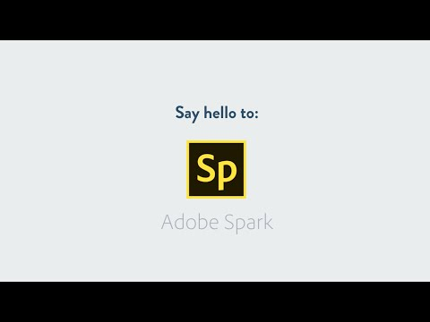
Sway  Part of the Office 365 suite of apps, Sway a cross between a presentation, website, and a digital book. Unlike PowerPoints, it allows for presentations to be more text heavy while still emphasizing images. Full range of collaboration tools makes it easy to get students working together. | 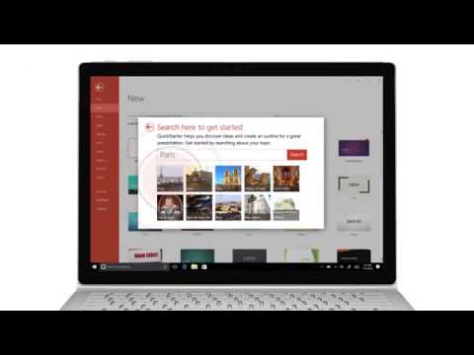
Padlet  A super easy way to share info, ideas, and allow for collaboration. Students call add to a wall, without editing or deleting someone else’s work. Text, images, videos, drawings, and more can all be added easily- no login required. Each user is allowed a limited number of Padlets for free.  Sample Padlets:  https://padlet.com/gallery/prompt1  https://padlet.com/elizabethpitel8/5eeujivw37cl  https://padlet.com/elizabethpitel8/537n9rl3fp8m  https://padlet.com/epitel/5ai56fbr4y7o |  | 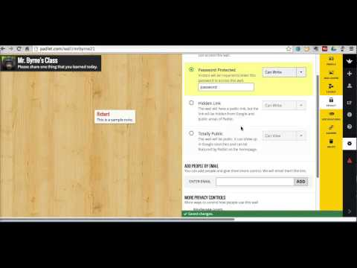
Educreations
Students can create their own lessons that combine images with recorded audio and drawing. Screens turn into interactive whiteboards where ideas and concepts can be explained through student voice an annotations.
Video Directions
Sample Lesson
Sample Lesson

Screencast-o-matic
Students can create their own lessons by adding voice to a video of their screen. A great way to have students explain their thinking and share with others.

Sample Video
Sample Video 2
OneNote  OneNote allows students to create digital binders where various media, graphics, text can be interacted with live. Students can annotate, record themselves, collaborate, and create. Inclusion of videos, links, spreadsheets, forms, drawing tools, and more allow for the ultimate flexibility in creation. Additionally, the collaboration space can be opened up and restricted to small groups so that students can work together in a wide variety of ways. Teachers have access to all student work at all times. Built in tools provide assistance to students with reading and writing disabilities. |  | 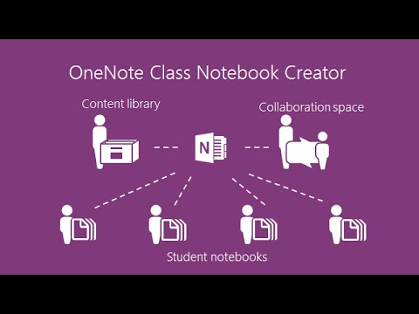
Flipgrid  Flipgrid is a social learning assessment tool. Students are able to make video recordings of themselves describing ideas, answering questions, or performing. In turn, other students and teachers can video responses back to the students. It has a wide array of uses in all subject areas.  FlipGrid samples and help |  | 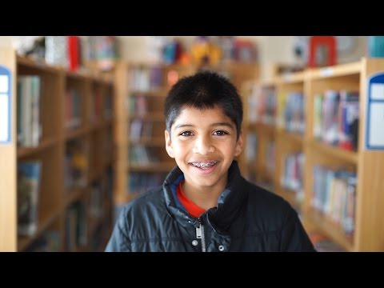
Weebly

Weebly is a website/blog creation tool that allows for students to publish their work to the world. By expanding their audience beyond their teachers and immediate classmates, students are motivated to improve the quality and frequency of their writing while connecting with the world.

Article: Edublogging

