Technology that is delivered to the individual space.
Nearpod- presentation tool that allows for assessment, collaboration, Virtual Reality, video access, simulations, in either the whole group or individual (italicized features are premium)  Sample lessons:  https://share.nearpod.com/yqJ1kJqzYL  Nearpod Help:  https://padlet.com/elizabethpitel8/c7s6f6jks1rz | What is Nearpod?  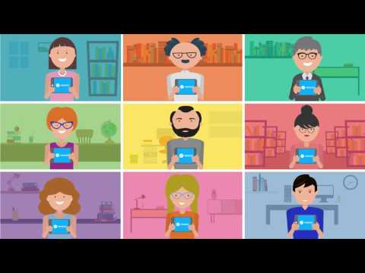  Nearpod Virtual Field Trips  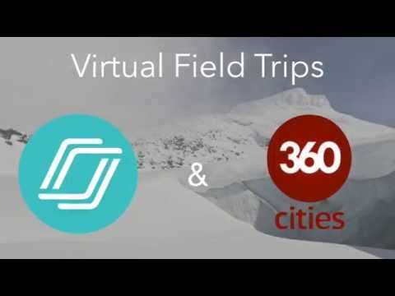
Edpuzzle/Playposit- Videos with embedded assessment. Students can access anywhere/ anytime.  Premium features allow for sharing and school based space  Samples:  EdPuzzle  PlayPosit | 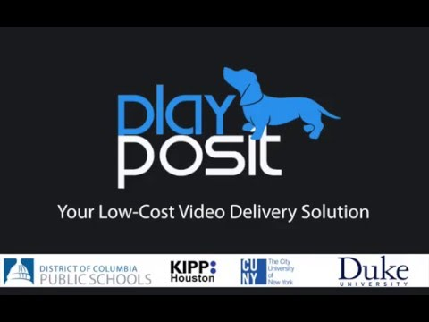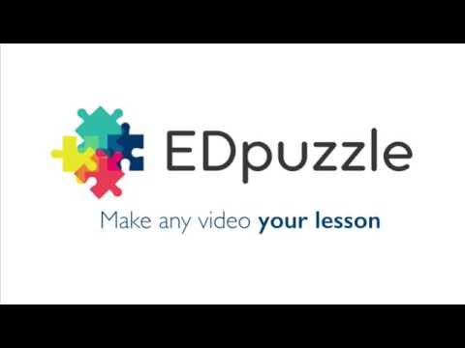
PowerPoint Recordings- Teachers and students can add voice overs to PowerPoints creating lectures and explanations that can viewed at any time. | 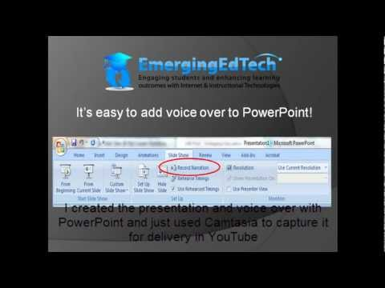
Screencast-o-matic: create screen casts of any screen to create a self-explained video of work.
OneNote- create digital binders where various media, graphics, text can be interacted can live. Students can annotate, record themselves, collaborate, and create. Teachers have access to all student work at all times. Built in tools provide assistance to students with reading and writing disabilities.  This sample notebook content library shows how OneNote can be used in a variety of ways! | OneNote online and full version- moving back and forth  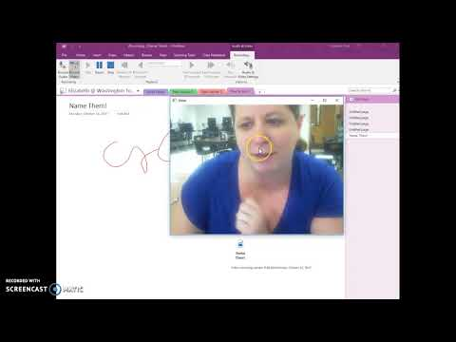  Class Notebook explained  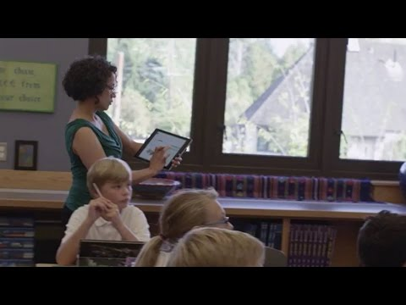  OneNote Learning Tools  